

The Egyptian E-Learning University (EELU)

Faculty of Computer & Information Technology

**" Tourism Guide Chat-bot"**

**By:**

|  |  |  |
| --- | --- | --- |
| **No.** | **Name** | **ID** |
| **1** | Mustafa Abo-Elhassan Maghraby | **17-00352** |
| **2** | Mina Helal | **19-00247** |
| **3** | Andrew Amir Albert | **20-00385** |
| **4** | Saber Ahmed Elsayed | **20-01314** |
| **5** | Mohamed Mahmoud Farouk | **20-01510** |
| **6** | Marco Abdo Gress | **20-01649** |
| **7** | Mahmoud Khaled Mohamed | **20-01682** |
| **8** | Mohamed Mahmoud Mohamed | **20-01871** |

**Under Supervision of:**

|  |  |
| --- | --- |
| **Dr. Rodaina Abdelsalam** | **Eng. Amany Emad** |
| - Doctor in Computer Science and Information Technology  Egyptian E-Learning University | - Teaching Assistant in Computer and Information Technology  Egyptian E-Learning University |

**Acknowledgment**

All Praises and Thanks Be to Allah for the success and his help for us to finish the project this year.

During this year we had to take advice and support from a boom of respectable people and we had to thank them for their time and effort and we would like to express our gratitude and thanks to them and we would like to show this to

our supervisors:

# Dr. Rodaina Abdelsalam

(Doctor in Computer Science and Information Technology

Egyptian E-Learning University)

# Eng. Amany Emad

(Teaching Assistant in Computer and Information Technology faculty At Egyptian E Learning University)

For giving us a good guideline for the Project throughout numerous consultations. We would also like to expand our deepest gratitude to all those who have directly and indirectly guided us in doing this Project.

Many people, especially our classmates and team members itself, have made valuable comment suggestions on this proposal which gave us an inspiration to improve our project. We thank all the people for their help directly and indirectly to complete our project.

**Abstract**

This project aims to enhance tourism in Egypt through an integrated digital platform featuring a web and mobile application, powered by an AI-driven chatbot and a sophisticated recommendation system

The platform is designed to offer personalized travel guidance and suggestions, improving the overall tourist experience with a focus on user-friendly navigation and engaging UI/UX design.

By leveraging machine learning algorithms for tailored recommendations and employing natural language processing for real-time assistance,

the project seeks to modernize tourism in Egypt, making it more accessible, convenient, and customized for visitors. This initiative not only aims to transform the visitor experience but also to support the growth of Egypt's tourism sector by promoting cultural and historical attractions through advanced technology.

In this project, we dealt with most of the problems that many new tourists face in Egypt, and we will see that in the project presentation, God willing.

**Chapter 1 Introduction**:

* 1. **Introduction:**

This project introduces an innovative approach to exploring Egypt, utilizing a digital platform that marries a web and mobile application with an AI-driven chatbot and a custom recommendation engine, all framed within an easily navigable UI/UX design. The chatbot, powered by advanced natural language processing, offers travelers immediate and personalized support, while the recommendation system crafts custom travel suggestions based on user preferences. With a focus on simplicity and engagement, the platform is crafted to be accessible to a wide range of users, streamlining the journey planning process and enhancing the overall experience of discovering Egypt’s rich cultural and historical offerings.

This endeavor not only aims to make travel planning more intuitive and enjoyable but also seeks to elevate Egypt’s tourism industry by drawing international attention to its myriad attractions through state-of-the-art technology and thoughtful design

**1.2 Problem Statement:**

The tourism sector in Egypt faces the challenge of effectively engaging a diverse and ever-growing international visitor base, ensuring they have access to up-to-date information and personalized travel experiences. While Egypt offers a wealth of health, cultural, and entertainment options, potential tourists may find it overwhelming to sift through the abundance of choices and logistical details necessary to plan their visit.

There is a need for a solution that can streamline the process of selecting activities, understanding service costs, and customizing travel itineraries to fit individual preferences and schedules. This solution must be capable of handling the complexities of Egypt's varied tourism landscape and must deliver this service in a user-friendly, accessible manner to enhance the overall experience of visiting Egypt.

**1.3 Motivation:**

The main idea of the app is to help people to visit the nearest ancient places around them that

they may do not know it has actually existed.

Project Help with:

• Give the visitor a good experience by letting him share moments and pic’s with others.

• Preparing plans for the most known places around him.

• Before the visitor go instructions helps him to get the most benefit of the journey.

• The user could act and communicate with other visitors using the social platform in the app.

**1.4 Project Phases:**

**• Phase 1: Study**

We seek to transform an abstract idea into a meaningful goal. At this point, we need to develop a feasibility study and define the project at a broad level. To do this, identify the need for the project and Determines details such as project constraints, objectives, projected schedule, etc.

**• Phase 2: Analysis**

Analysis can be as thorough or simple as you like and the information gathered can be helpful in current or future decision-making. It is helpful to conduct this information regularly, as the information can change quickly during volatile times.

**• Phase 3: Design**

The requirement gathered in document that is used as an input, software architecture that is used for implementing system development is derived.

**• Phase 4: Development**

The Development Phase features a key step in the system construction. The previous phases lay the foundation for system development; the following phases ensure that the system functions as required.

**• Phase 5: Implementation**

Includes the testing, inspection, adjustment, correction and certification of facilities and systems to ensure that the project performs as specified. The implementation phase begins with the notice to proceed for the construction contract and ends with final acceptance of the project, unless otherwise specified in grant or regulatory requirements.

**• Phase 6: Validation**

This stage evaluates/qualifies the process designed earlier to ensure it can reproduce consistent and reliable levels of quality.

**• Phase 7: follow up**

The follow-up phase serves to ensure that all recommendations given after the basic audit are implemented by the deadline. Different areas of responsibility are distinguished in the overall process and it breaks down into four sub-phases: status check I, follow-up I, status check II, and follow-up II

**Chapter 2 Background**

1. **Artificial Intelligence AI**:

refers to the simulation of human intelligence in machines that are programmed to think and learn. AI can be broadly categorized into:

1. **Narrow AI (Weak AI)**: AI systems that are designed to perform a narrow task (e.g., facial recognition, internet searches, or driving a car).
2. **General AI (Strong AI)**: AI systems with generalized human cognitive abilities, which can solve a variety of tasks with human-like intelligence (this is largely theoretical at this point).

**Key Components of AI:**

* **Machine Learning (ML)**: A subset of AI that involves the use of algorithms and statistical models to enable a system to improve its performance on a task through experience. Key types of ML include supervised learning, unsupervised learning, and reinforcement learning.
  + - **Deep Learning**: A subset of ML involving neural networks with many layers (deep neural networks). It is particularly powerful for tasks like image and speech recognition.
    - **Natural Language Processing (NLP)**: A field of AI focused on the interaction between computers and humans through natural language. It involves tasks like text generation, sentiment analysis, and language translation.
    - **Computer Vision**: A field of AI that enables machines to interpret and make decisions based on visual input from the world.
* **Flask**

**Flask** is a lightweight, micro web framework written in Python. It is designed to make getting started quick and easy, with the ability to scale up to complex applications. Flask is known for its simplicity, flexibility, and fine-grained control.

**Key Features of Flask:**

* **Minimalistic**: Flask provides the essentials to get a web server running, without too many built-in features, allowing developers to add libraries and extensions as needed.
* **Flexible**: It offers a lot of flexibility in terms of how you structure your application and what libraries you integrate.
* **RESTful**: Flask is commonly used to create RESTful APIs, making it a popular choice for backend services.
* **Jinja2**: A powerful templating engine that comes with Flask, enabling you to generate HTML dynamically.
* **Chatbots**

**Chatbots** are AI programs that can simulate conversations with users. They can be text-based or voice-based and are used in various applications like customer service, personal assistants, and informational services.

**Types of Chatbots:**

1. **Rule-Based Chatbots**: These chatbots follow predefined rules and scripts. They are simple to implement but are limited in their ability to handle complex queries.
2. **AI-Based Chatbots**: These use machine learning and NLP to understand and respond to user queries in a more natural and flexible manner. They can learn from interactions and improve over time.

* **Key Components of Chatbots:**
* **Natural Language Understanding (NLU)**: The ability to understand and interpret user inputs.
* **Natural Language Generation (NLG)**: The ability to generate human-like responses.
* **Dialogue Management**: Handling the flow of the conversation and maintaining context.
* **Integration**: Connecting with other services, databases, or APIs to provide more comprehensive responses.
* **Combining AI, Flask, and Chatbots**

By combining AI, Flask, and chatbots, you can create sophisticated web applications with intelligent conversational interfaces. Here’s a high-level overview of how these technologies can work together:

1. **Developing the Chatbot**:

* Use NLP libraries or services (like spaCy, NLTK, or cloud-based services like Dialogflow or Microsoft Bot Framework) to create the chatbot.
* Train the chatbot using machine learning models to improve its understanding and responses.

1. **Creating the Backend with Flask**:

* Set up a Flask server to handle incoming HTTP requests from the chatbot interface.
* Create endpoints to handle different chatbot functionalities, such as retrieving data, processing user inputs, and managing sessions.

1. **Integrating the Chatbot with Flask**:

* Use Flask to serve the chatbot interface (web page or mobile app).
* Connect the chatbot logic to Flask endpoints to handle user interactions and fetch necessary data.

1. **Deploying the Application**:

* Deploy the Flask application on a web server (e.g., using platforms like Heroku, AWS, or Google Cloud).
* Ensure the chatbot is accessible via the web interface and can interact with users in real-time.

### **Example: Basic Chatbot with Flask**

Here’s a simple example of integrating a rule-based chatbot with Flask:

1. **Install Flask**:

bash

Copy code

pip install flask

1. **Create the Flask App**:
2. **Run the Application**:
3. **Test the Chatbot**:

Use a tool like Postman or curl to send a POST request to

This example showcases a simple rule-based chatbot integrated with a Flask server. For a more advanced AI-based chatbot, you would replace the generate response function with a model that uses NLP techniques to understand and generate responses.

**Summary**

Combining AI, Flask, and chatbots allows developers to create intelligent, interactive web applications. Flask serves as the backend framework to handle HTTP requests and manage application logic, while AI technologies (particularly NLP) enable the creation of sophisticated chatbots capable of understanding and responding to user queries. This combination can be deployed across various platforms, offering users a seamless and engaging experience.

**2. UI-UX:**

UI (User Interface) and UX (User Experience) design are crucial aspects of creating effective and engaging digital products. Figma is a powerful tool that facilitates both UI and UX design processes. Here's an in-depth explanation of UI, UX, and how Figma supports these design activities.

**Understanding UI and UX**

User Interface (UI)

UI design focuses on the look and feel of a product's interface. It involves designing the visual elements that users interact with, including buttons, icons, typography, colors, and layouts.

**Key aspects of UI design:**

* **Visual Design**: Crafting the aesthetic elements of the interface, such as color schemes, typography, and iconography.
* **Layout**: Organizing elements on the screen in a visually appealing and functional manner.
* **Interactivity**: Designing how elements respond to user actions, such as clicks, swipes, and hovers.

User Experience (UX)

UX design encompasses the overall experience a user has while interacting with a product. It focuses on making the product intuitive, efficient, and enjoyable to use.

**Key aspects of UX design:**

* **User Research**: Understanding the needs, behaviors, and pain points of users through methods like interviews, surveys, and usability testing.
* **Information Architecture**: Structuring and organizing content in a way that makes it easy for users to find what they need.
* **Wireframing and Prototyping**: Creating low-fidelity and high-fidelity representations of the product to visualize and test its functionality.
* **Usability Testing**: Evaluating the product with real users to identify areas for improvement.

**Figma for UI/UX Design**

**Figma** is a web-based design tool that enables designers to create, collaborate, and prototype UI/UX designs. It is known for its collaborative features, making it a popular choice for teams.

**Key Features of Figma**

1. **Real-Time Collaboration**
   * Multiple designers can work on the same project simultaneously, seeing each other's changes in real-time. This enhances teamwork and reduces the need for back-and-forth communication.
2. **Vector Editing**
   * Figma offers powerful vector editing tools, allowing designers to create scalable and precise designs. This is essential for creating high-quality UI elements
3. **Components and Design Systems**

* Designers can create reusable components (e.g., buttons, icons) that can be used across multiple projects. Figma also supports design systems, enabling consistency and efficiency in large projects.

1. **Prototyping**

* Figma allows designers to create interactive prototypes with clickable elements, transitions, and animations. This helps in visualizing the user flow and testing interactions.

1. **User Testing**

* Prototypes created in Figma can be shared with stakeholders or testers via a URL. Feedback can be gathered directly on the design, streamlining the user testing process.

1. **Plugins and Integrations**

* Figma supports various plugins that extend its functionality, such as accessibility checkers, design systems managers, and animation tools. It also integrates with other tools like Slack, Jira, and Zeplin.

**Designing a UI/UX Project with Figma**

Here’s a step-by-step guide to using Figma for a UI/UX design project:

1. **Set Up the Project**

* Create a new project in Figma and set up frames (artboards) for different screens or sections of your application.

1. **Conduct User Research**

* Gather insights about your users through surveys, interviews, and observations. Document your findings and create user personas to guide your design decisions.

1. **Create Wireframes**

* Start with low-fidelity wireframes to outline the basic structure and layout of your application. Focus on the user flow and ensure that navigation is intuitive.

1. **Design High-Fidelity Mockups**

* Develop high-fidelity designs by adding visual details like colors, typography, and images. Use Figma's vector tools and design components to create a polished UI.

1. **Build Interactive Prototypes**

* Link your screens and add interactions to create a clickable prototype. Define transitions and animations to simulate the real user experience.

1. **Test and Iterate**

* Share your prototype with stakeholders and users to gather feedback. Use Figma’s commenting feature to collect input directly on the design. Iterate on your design based on the feedback.

1. **Develop a Design System**
   * If you’re working on a larger project, create a design system in Figma. Define reusable components, styles, and guidelines to maintain consistency across your project.

**Example Workflow in Figma**

1. **Creating a Frame**

* Start by creating a new frame for your main screen. Choose the appropriate size (e.g., iPhone, desktop) from the frame presets.

1. **Adding Components**

* Design reusable components such as buttons, input fields, and navigation bars. Use Figma’s component feature to create instances that can be easily updated across the project.

1. **Applying Styles**

* Define and apply consistent styles for colors, text, and effects. Use Figma’s styles feature to manage and update styles across the entire project.

1. **Prototyping Interactions**

* Use the Prototype tab to link different frames and add interactions. Define how users will navigate through your application by setting up triggers (e.g., on click, on hover) and transitions.

1. **Sharing and Collaboration**

* Share your Figma file or prototype link with team members or stakeholders. Use the commenting feature to gather feedback and make collaborative edits in real-time.

**Summary**

UI/UX design is a critical part of creating successful digital products, focusing on the visual appeal and overall user satisfaction. Figma provides a comprehensive suite of tools for designing, prototyping, and testing user interfaces and experiences. Its collaborative features, vector editing capabilities, and support for design systems make it a powerful tool for UI/UX designers working on projects of any size

**3.Web Application:**

**3.1 Frontend technology**

refers to the set of tools, frameworks, and practices used to create the user interface and user experience of web applications. The frontend, or client-side, is what users interact with directly in their web browsers. Here's an in-depth look at the key components and concepts:

**Core Technologies**

1. **HTML (HyperText Markup Language)**

* **HTML**: The foundational markup language used to structure content on the web. It defines elements such as headings, paragraphs, links, images, and forms.

1. **CSS (Cascading Style Sheets)**

* **CSS**: A style sheet language used to describe the presentation of HTML elements. It controls layout, colors, fonts, and overall visual appearance.
* **CSS3**: The latest evolution of CSS, introducing new features such as flexbox, grid layout, animations, and transitions.

1. **JavaScript**

* **JavaScript**: A versatile, high-level programming language that enables interactive web pages. It can manipulate the DOM (Document Object Model), handle events, validate forms, and more.

**Modern JavaScript Frameworks and Libraries.**

**CSS Frameworks and Preprocessors**

1. **Bootstrap**

* **Bootstrap**: A widely-used CSS framework developed by Twitter, offering a collection of pre-designed components, grid systems, and responsive design utilities.

1. **Tailwind CSS**

* **Tailwind CSS**: A utility-first CSS framework that provides low-level utility classes to build custom designs without leaving the HTML.

1. **Sass (Syntactically Awesome Style Sheets)**

* **Sass**: A CSS preprocessor that adds features like variables, nested rules, and mixins, making CSS more maintainable and scalable.

1. **Less**

* **Less**: Another CSS preprocessor similar to Sass, which extends CSS with dynamic behavior such as variables and functions.

**Build Tools and Package Managers**

**Other Key Tools and Concepts**

**Development Tools**

1. **Code Editors/IDEs**

* **Visual Studio Code**: A popular code editor with robust support for JavaScript, HTML, CSS, and frameworks like React and Angular through extensions.
* **WebStorm**: An IDE from JetBrains tailored for JavaScript development, offering extensive support for modern frameworks and tools.

1. **Browser Developer Tools**
   * **DevTools**: Built-in tools in modern web browsers (like Chrome, Firefox, and Edge) for debugging, inspecting HTML/CSS, monitoring network activity, and analyzing performance.
2. **Version Control**

* **Git**: A version control system that tracks changes in source code during software development, enabling collaboration and history tracking.
* **GitHub/GitLab**: Platforms for hosting and managing Git repositories, providing features for code review, CI/CD, and project management.

**Summary**

Frontend technology encompasses a wide array of tools and frameworks aimed at creating rich, interactive user interfaces for web applications. Core technologies like HTML, CSS, and JavaScript form the foundation, while modern frameworks and libraries such as React, Angular, Vue.js, and Svelte enhance development efficiency and performance. CSS frameworks and preprocessors, along with build tools and package managers, streamline the development process. Tools like TypeScript, AJAX, and GraphQL further enhance the capabilities of frontend development, ensuring that applications are dynamic, scalable, and maintainable.

**2.2 Backend**

**.**NET technology refers to a set of tools, libraries, and frameworks developed by Microsoft for building the server-side logic of web applications, desktop applications, services, and more. Here's a comprehensive overview of the key components and concepts:

### **.NET Framework**

* **.NET Framework**: An original and mature platform primarily for building Windows applications. It includes a large class library called the Framework Class Library (FCL) and provides language interoperability across several programming languages.

### **.NET Core**

* **.NET Core**: A cross-platform, open-source framework that allows developers to build applications that run on Windows, macOS, and Linux. It was designed to overcome the limitations of the .NET Framework in terms of cross-platform compatibility.

### **.NET 5 and Beyond**

* **.NET 5/6/7**: These are the unified evolution of .NET Core and the .NET Framework, bringing together the best features of both platforms. .NET 5 and beyond are cross-platform, open-source, and designed to work on various types of applications, including web, mobile, desktop, gaming, and IoT.

### **Key Components**

1. **ASP.NET Core**

* **ASP.NET Core**: A high-performance, cross-platform framework for building modern, cloud-based, internet-connected applications. It is particularly used for web applications, RESTful APIs, and real-time web applications.
* **Razor Pages**: A simplified web programming model for building server-side rendered web pages.
* **MVC (Model-View-Controller)**: A design pattern for creating web applications with a clear separation of concerns.
* **Blazor**: A framework for building interactive web UIs using C# instead of JavaScript. Blazor can run client-side in the browser via WebAssembly or server-side.

1. **Entity Framework Core (EF Core)**

* **EF Core**: An Object-Relational Mapper (ORM) that simplifies data access by allowing developers to work with a database using .NET objects, eliminating much of the data-access code.

1. **SignalR**

* **SignalR**: A library for adding real-time web functionality to applications. It allows server-side code to push content to clients instantly.

1. **gRPC**

* **gRPC**: A high-performance RPC (Remote Procedure Call) framework used to communicate between services, which is particularly useful in microservices architectures.

1. **.NET CLI**
   * **.NET CLI**: A command-line interface for .NET, used for creating, building, running, and publishing .NET applications.
2. **NuGet**
   * **NuGet**: A package manager for .NET, which provides access to a large repository of reusable code in the form of packages.

### **Languages**

* **C#**: The primary programming language for .NET, known for its versatility, modern syntax, and performance.
* **F#**: A functional-first language that also supports object-oriented and procedural programming.
* **Visual Basic .NET (VB.NET)**: An approachable language with a simple syntax, historically used for Windows applications.

### **Development Tools**

* **Visual Studio**: The most popular integrated development environment (IDE) for .NET development, offering a comprehensive suite of tools for coding, debugging, and deployment.
* **Visual Studio Code**: A lightweight, cross-platform code editor that supports .NET development with various extensions.

### **Common Applications**

* **Web Applications**: Using ASP.NET Core, developers can create robust and scalable web applications.
* **APIs**: .NET is often used to build RESTful APIs or gRPC services for microservices architectures.
* **Desktop Applications**: With frameworks like Windows Presentation Foundation (WPF) and Windows Forms, .NET is widely used for desktop application development.
* **Mobile Applications**: Xamarin (now part of .NET MAUI) allows developers to create cross-platform mobile applications using .NET.
* **Cloud Services**: .NET applications can be easily deployed to cloud platforms such as Microsoft Azure.

### **Key Features**

* **Cross-Platform**: .NET Core and subsequent versions support multiple operating systems.
* **High Performance**: .NET is optimized for performance, especially with .NET Core and later versions.
* **Scalability**: Suitable for building large-scale, distributed systems.
* **Security**: Provides robust security features to protect applications from common vulnerabilities.

### **Summary**

Backend .NET technology encompasses a wide range of tools and frameworks that make it possible to build scalable, high-performance, and secure applications. It supports a variety of application types, from web and desktop to mobile and cloud-based services, all while providing cross-platform compatibility and robust developer tools.

**4.MOBILE APPLICATION:**

Flutter is an open-source UI software development kit (SDK) created by Google. It is used to build natively compiled applications for mobile (Android and iOS), web, and desktop from a single codebase. Flutter has gained significant popularity due to its fast development cycle, expressive and flexible UI, and high performance.

### **Key Features of Flutter**

1. **Single Codebase**
   * Flutter allows developers to write one codebase and deploy it across multiple platforms, including Android, iOS, web, and desktop (Windows, macOS, Linux).
2. **Dart Language**
   * Flutter applications are written in Dart, a programming language developed by Google. Dart is optimized for client-side development, with features like a sound type system, async-await, and a rich standard library.
3. **Hot Reload**
   * Hot reload allows developers to see changes to the code immediately in the app without restarting it. This feature significantly speeds up the development process and improves productivity.
4. **Widgets**
   * Flutter uses a widget-based architecture, where everything is a widget. Widgets are the building blocks of a Flutter app, representing all elements of the UI. Flutter provides a rich set of pre-designed widgets and allows for custom widget creation.
5. **Expressive and Flexible UI**
   * Flutter’s widget library includes a wide range of customizable widgets for building complex and expressive UIs. Developers can create custom animations, transitions, and interactions with ease.
6. **Performance**
   * Flutter provides high performance by compiling Dart code to native ARM code for mobile platforms. This results in smooth animations and quick load times.
7. **Material Design and Cupertino**
   * Flutter includes built-in support for Material Design (Google’s design language) and Cupertino (Apple’s design language), allowing developers to create UIs that look and feel native on both Android and iOS.
8. **Plugins and Packages**
   * The Flutter ecosystem has a vast collection of packages and plugins that extend its capabilities, such as accessing device hardware, integrating with third-party services, and more.

### **Core Components of Flutter**

1. **Flutter Engine**
   * The Flutter engine is written primarily in C++ and provides low-level rendering support using Google’s Skia graphics library. It also handles text layout, plugin architecture, and Dart runtime.
2. **Foundation Library**
   * This library provides the basic classes and functions needed to build Flutter applications. It includes APIs for handling animations, gestures, and input.
3. **Widgets Library**
   * The widgets library includes a comprehensive set of pre-built widgets for building UIs. It covers layout, styling, navigation, and more.
4. **Dart Platform**
   * Dart is the language used for writing Flutter applications. It features ahead-of-time (AOT) compilation for building native binaries and just-in-time (JIT) compilation for a fast development cycle.

### **Building a Flutter App**

1. **Setup**
   * To start building with Flutter, you need to install the Flutter SDK and set up an IDE such as Android Studio, Visual Studio Code, or IntelliJ IDEA with the Flutter and Dart plugins.
2. **Project Structure**
   * A typical Flutter project has a specific structure, including folders for assets, lib (the main code), and test (for unit tests). The main. dart file serves as the entry point for the application.
3. **Writing Code**
   * Flutter code is written in Dart. A simple Flutter app might look like this:
4. **Hot Reload**
   * During development, you can make changes to the code and use hot reload to see the results instantly.
5. **Building and Deploying**
   * Once the app is developed, you can build it for different platforms using Flutter’s build tools. For example, you can generate APK files for Android or IPA files for iOS.

### **Use Cases**

* **Mobile Apps**: Flutter is widely used for developing mobile applications for both Android and iOS platforms.
* **Web Applications**: Flutter for web allows you to create responsive web applications with the same codebase.
* **Desktop Applications**: Flutter supports creating desktop applications for Windows, macOS, and Linux, providing a unified development experience.

### **Summary**

### Flutter is a powerful and versatile framework for building cross-platform applications. Its key features, such as a single codebase, hot reload, and a rich set of customizable widgets, make it an attractive choice for developers. With support for multiple platforms and a strong community, Flutter continues to grow as a popular tool for modern app development

**Chapter 3**

**Implementation**

1. **UI-UX:**

FIRST PAGE HOME PAGE THAT SHOWES THE USER A BREIF ABOUT EGYPT AND TRENDING PLACES NOW

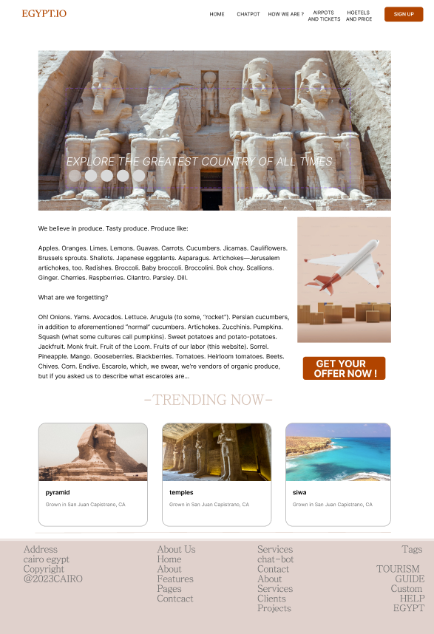

SECOND PAGE PACKAGE PAGE THAT SHOWES THE USER MANY PACKAGES AND HE CHOOSE WHAT SUIT HIM IN THOSE

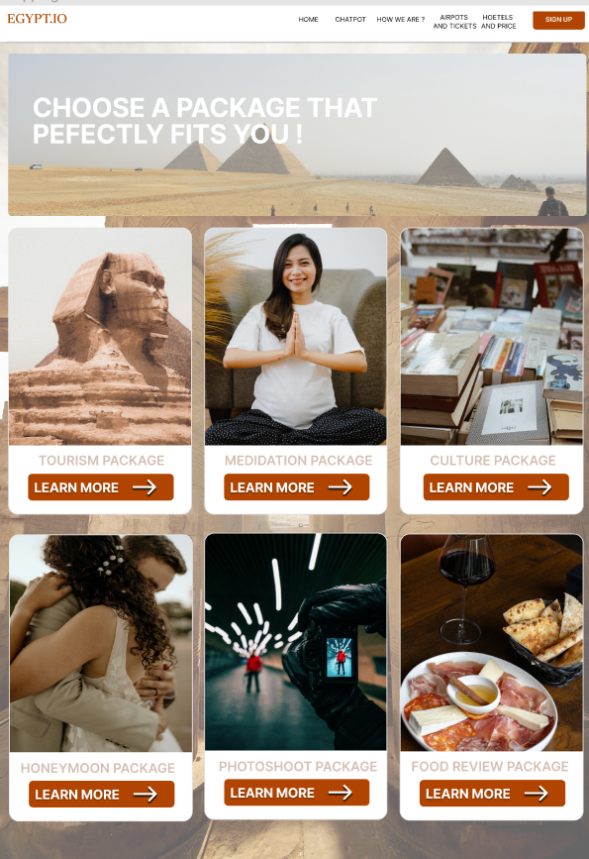

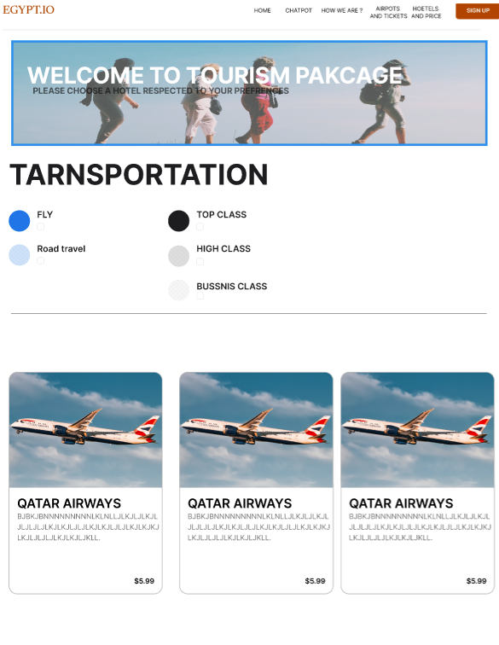THIRD PAGE IF HE CHOOSE TOURISM PACKAGE IN PACKAGE PAGE WELL APPEAR TRANSPOARTATION PAGE FOR TOURISM PACKAGE THAT SHOWES THE USER MANY TRANSPOARTATION WAYS AND HE CHOOSE WHAT SUIT HIM IN THOSE

FOURTH PAGE IF HE CHOOSE TOURISM PACKAGE IN PACKAGE PAGE WELL APPEAR AFTER TRANSPOARTATION PAGE A HOTELS PAGE FOR TOURISM PACKAGE THAT SHOWES THE USER MANY HOTELS AND HE CHOOSE WHAT SUIT HIM IN THOSE

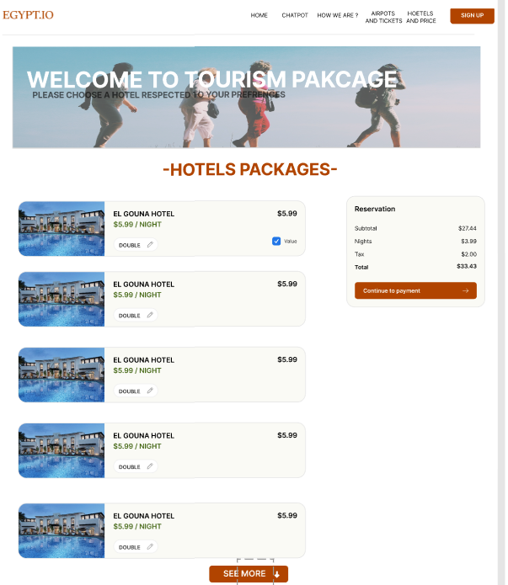

FIFTH PAGE IF HE CHOOSE TOURISM PACKAGE IN PACKAGE PAGE WELL APPEAR AFTER TRANSPOARTATION PAGE AND HOTELS PAGE FOR TOURISM PACKAGE THAT SHOWES THE USER MANY TOURISM SITES AND PLACES AND HE CHOOSE WHAT HE WANT TO VISIT

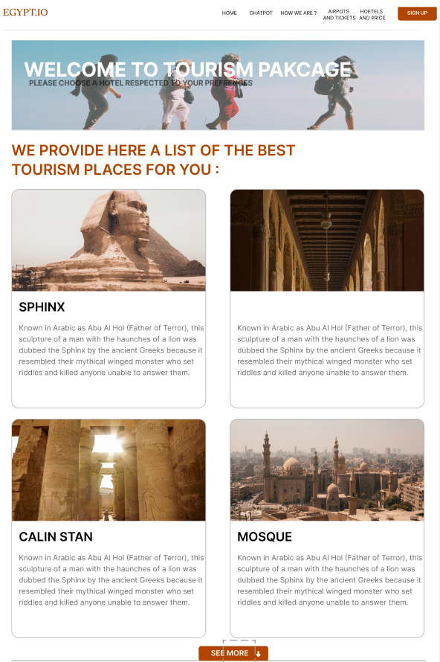

1. **WEB APPLICATION:**

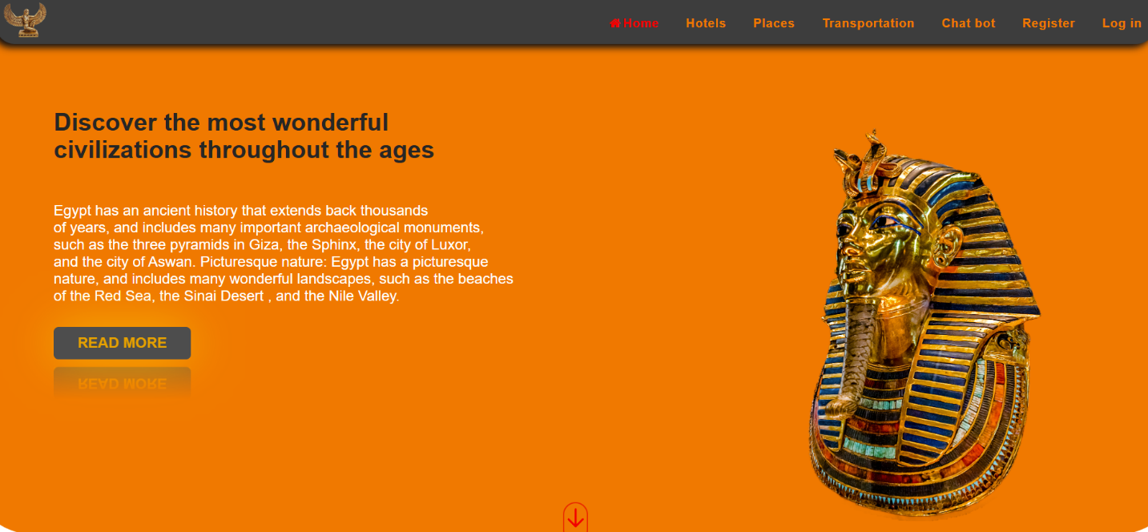

**FIRST THE HOME PAGE WITH A BERIF ABOUT EGYPT**

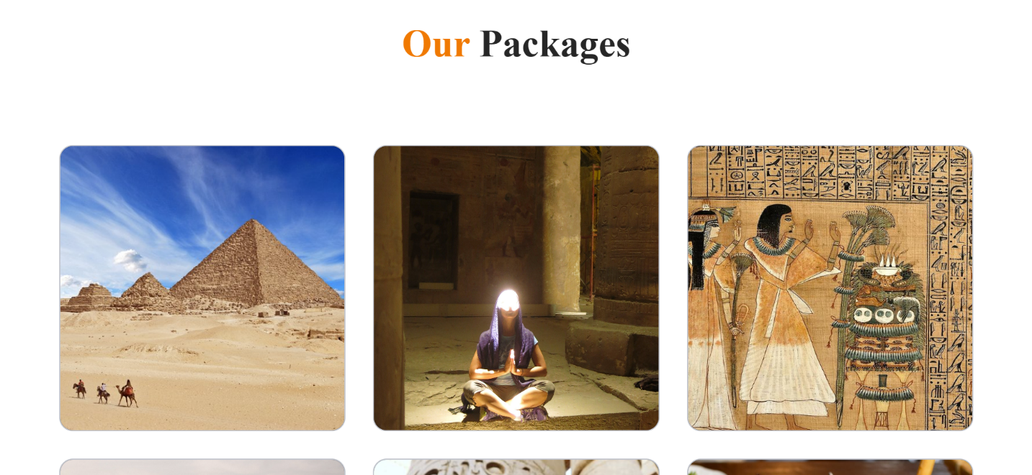

**THE MIDDLE SECTION OF IT SHOW A VARITY OF SPECIALIZED PACKAGES**

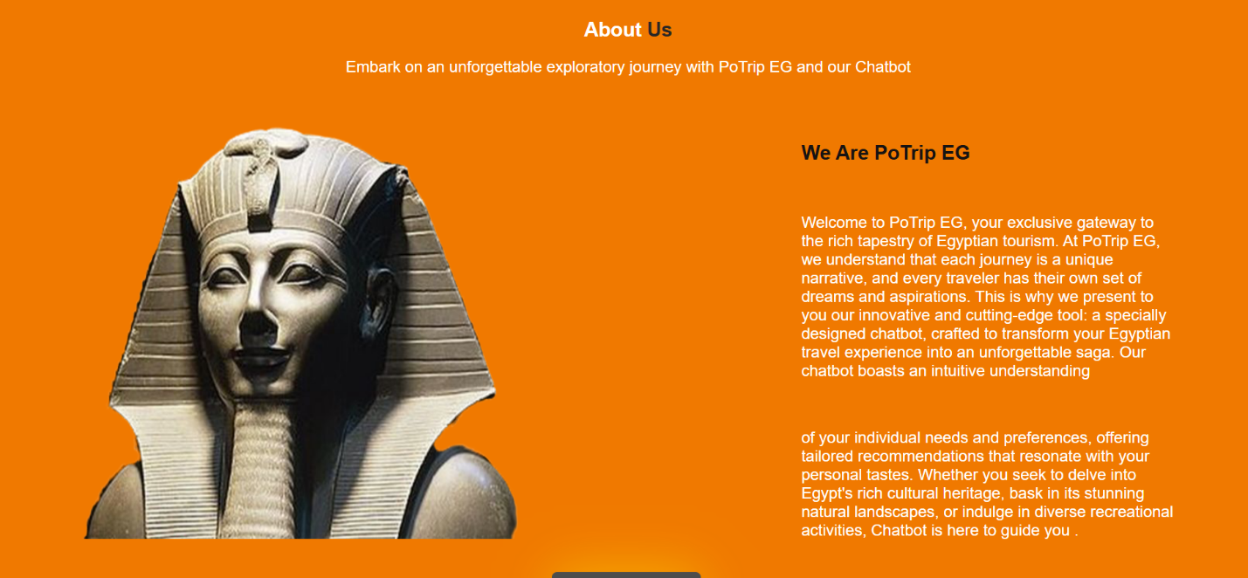

**THE THIRD PART OF IT IS ABOUT US SECTION WHICH TELL THE USER MORE INFO ABOUT THE PROJECT**

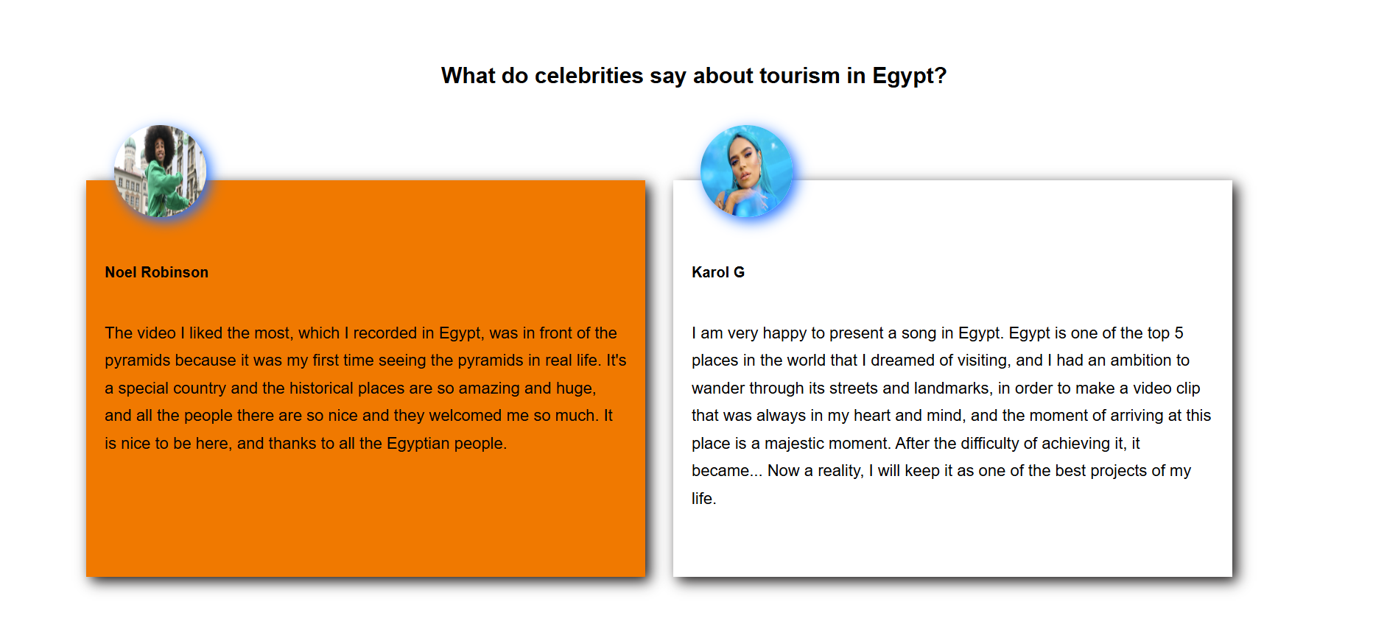

**THE LAST PART SHOW FAMOUS CELEBRITIES’ OPINIONS**



**THE FOOTER PART THAT HAVE COMMUNICATIONS AND OUR LINKS**

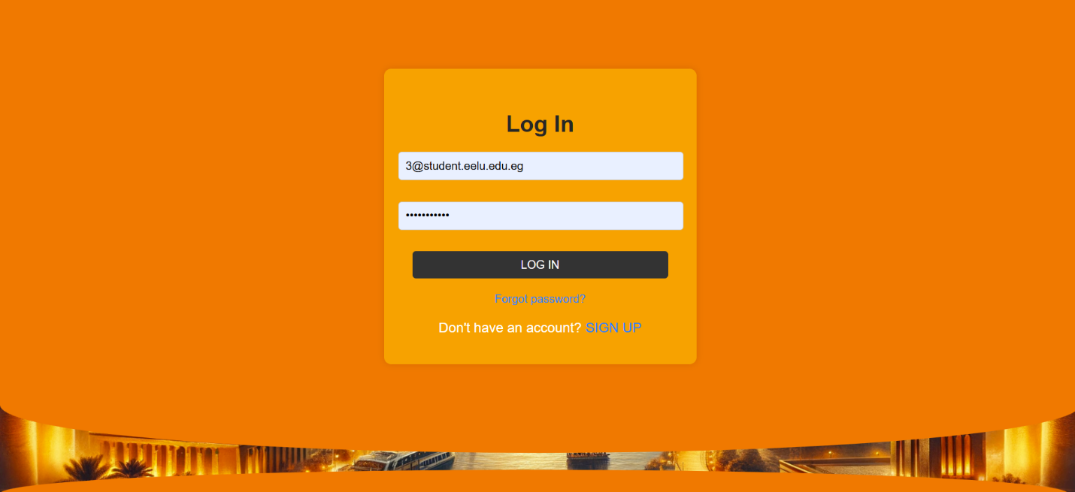

**THE LOGIN PAGE**

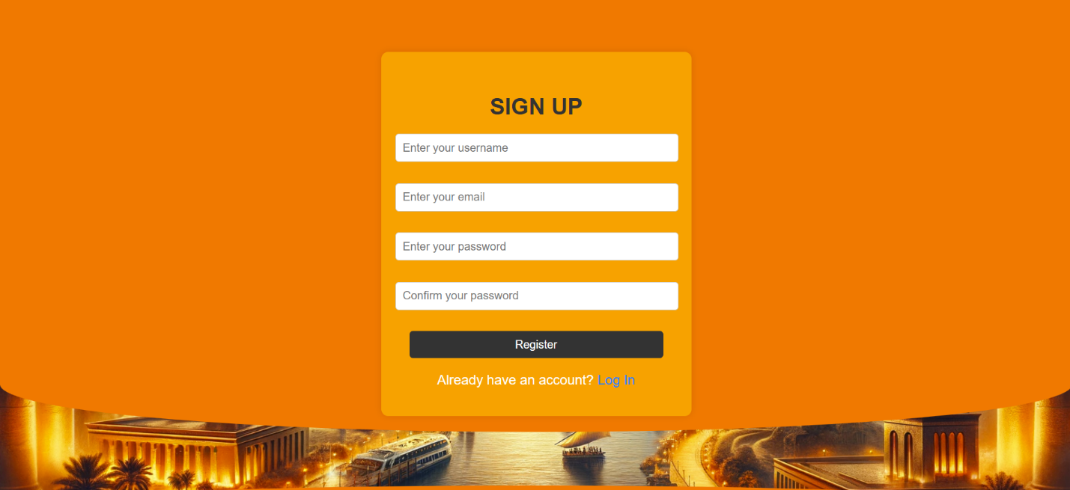

**THE SIGN UP PAGE**

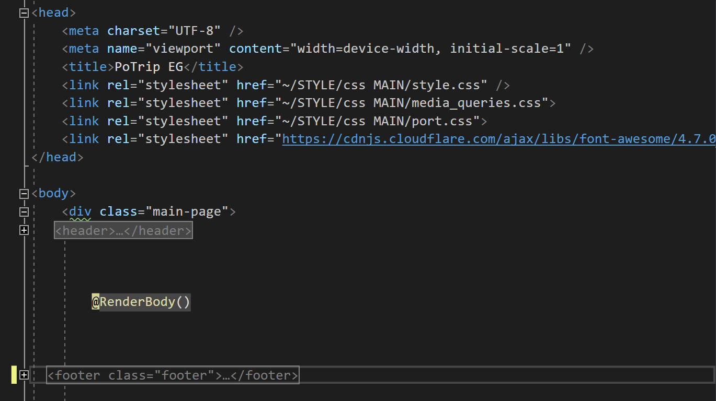

**THE LAYOUT PAGE TAKES THE STATIC PART IN THE WEBSITE THAT DOSE NOT CHANGE LIKE NAVIGATION PAR AND THE FOOTER**

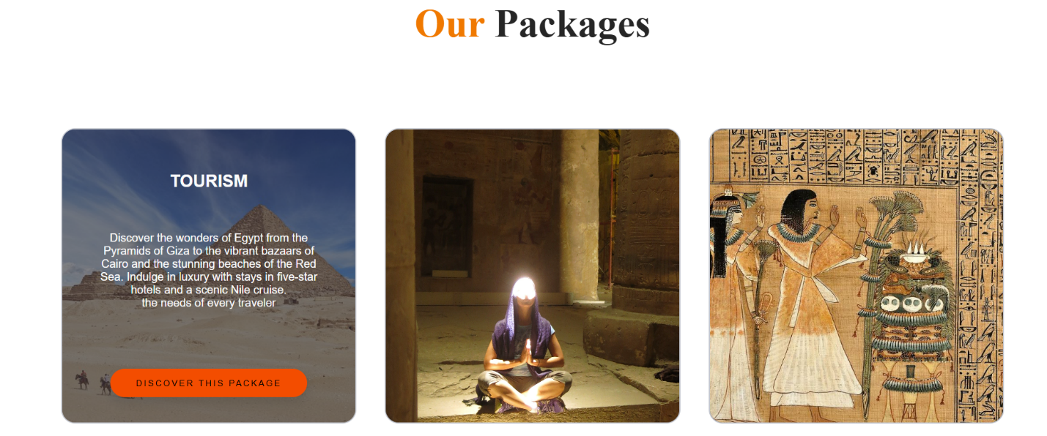

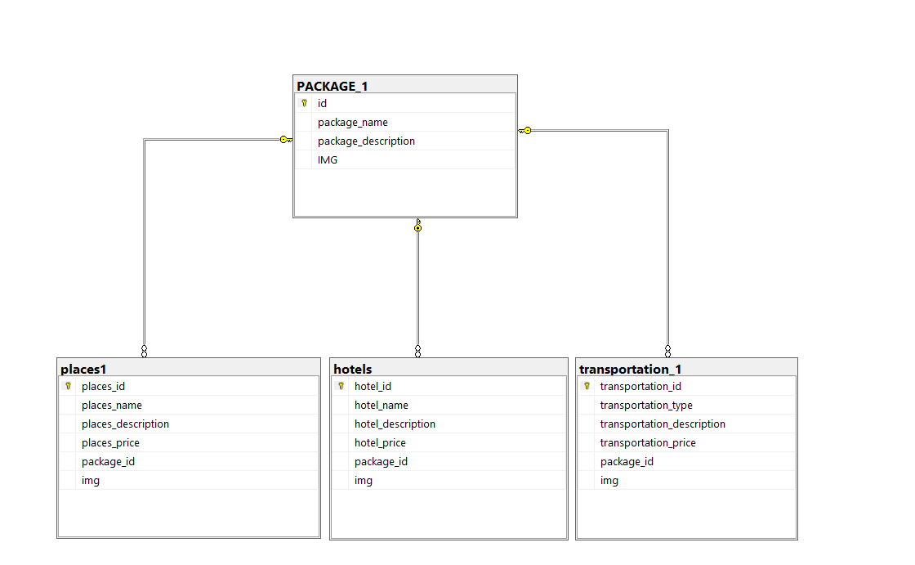

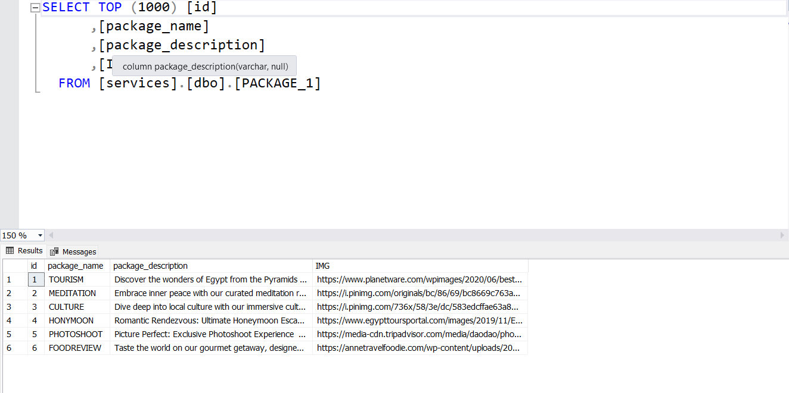

**WE MAKE A DATABASE WITH MULTIPLE PACKAGES EACH PACKAGE REDIRECT THE USER OF MULTIPLE OTHER INTRESTS**

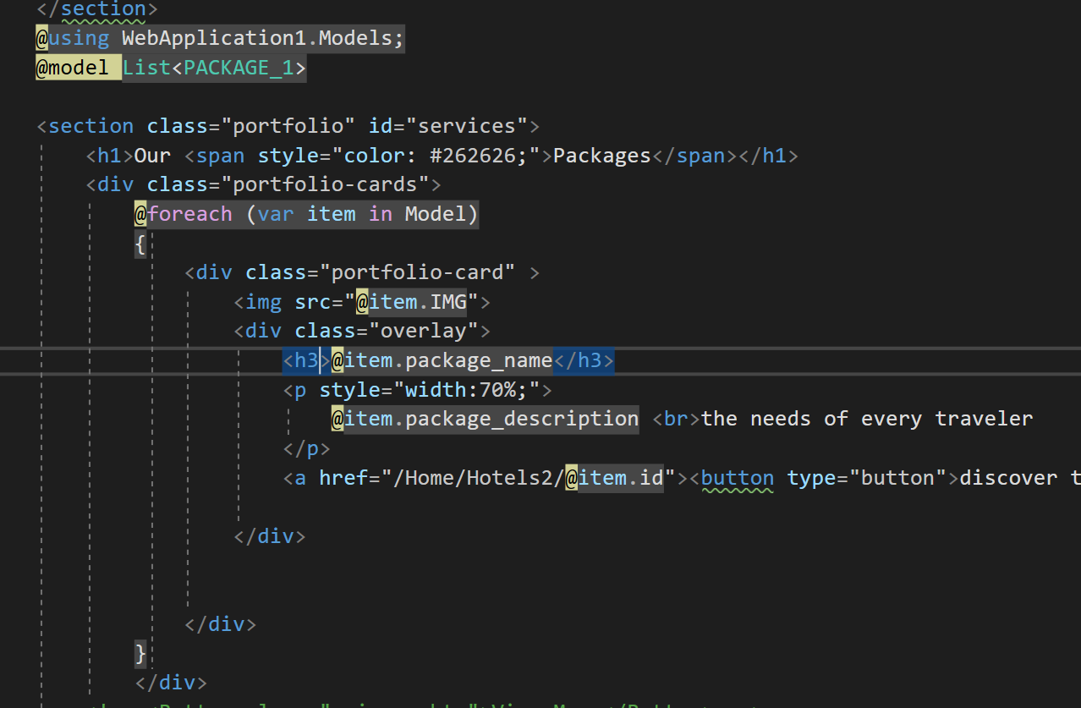

WE CONNECT THE DATABASE WITH THE MODEL TO TAKE THE DATA AND PUT IT IN THE FRONT END PART

WHICH IS SECTION THAT CHANGE DYNAMICALLY DEPEND ON THE CONTROLS ON IT AND ITERATE DEPENDING ON THE NUMBER OF ELEMNTS

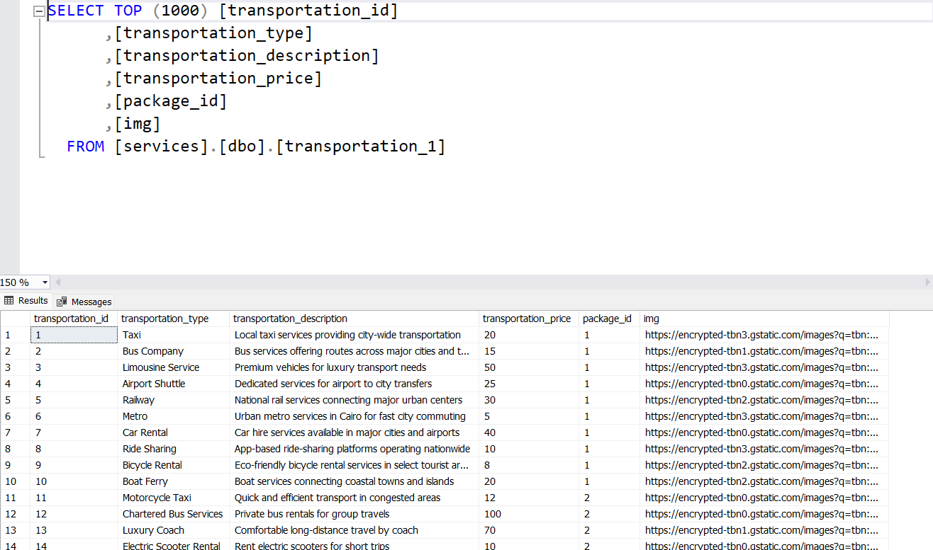

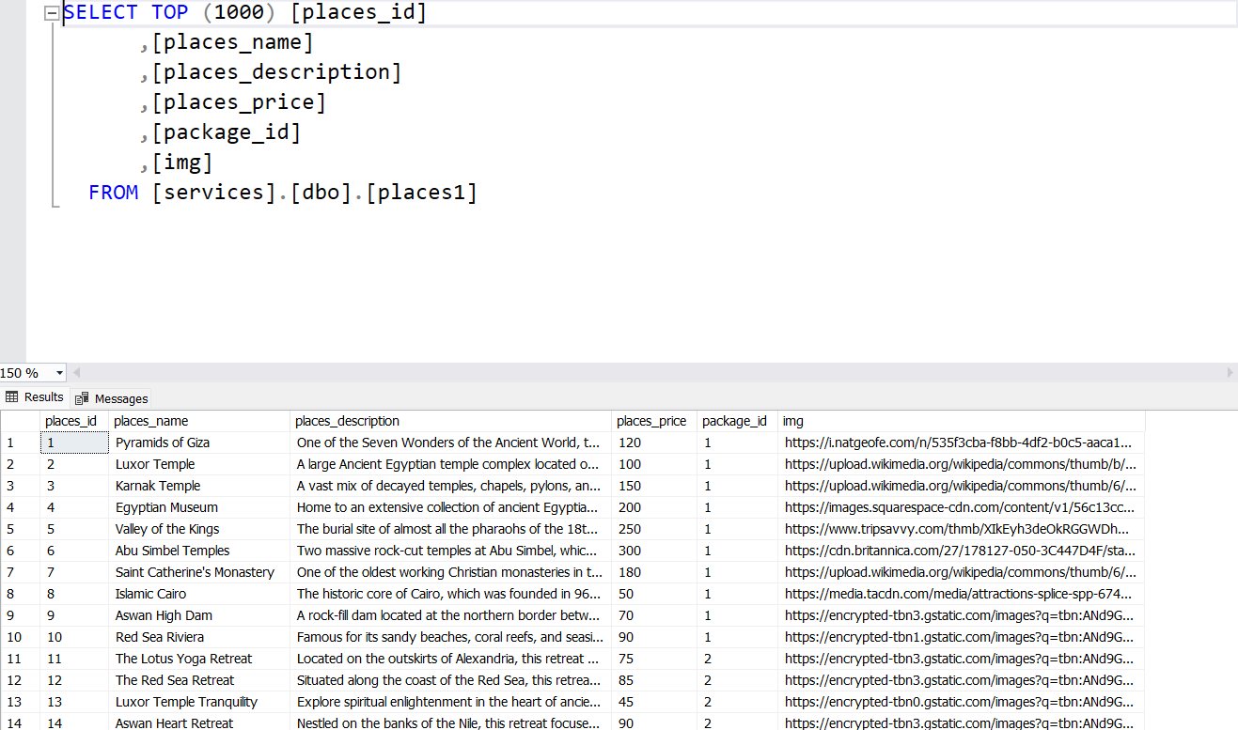

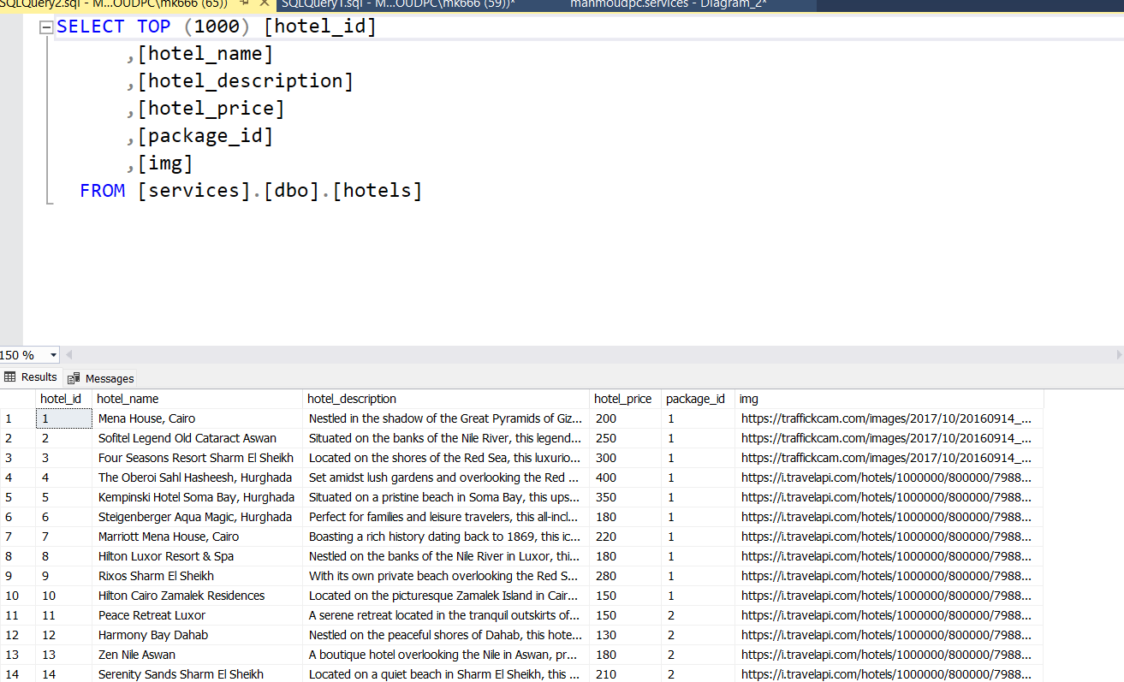

**WE MAKE A 3 TABELS OF EACH ONE OF THE PAGES WE REDIRECT THE USER TO AFTER THE PACKAGE CHOICE, WE SPECIFY A 60 COLUMNS**

**10 FOR EACH PACKAGE**

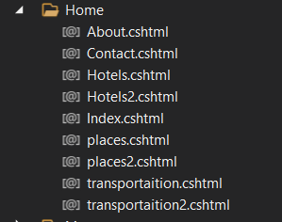

**AND MAKE 2 VIEWS FOR EACH PAGE ONE THE SHOWS ALL THE 60 CHOICES AND THE OTHER VIWE THAT THE USER RESULTING FROM THE PACKAGE CHOICE THE SHOWS A 10 FILTTERD RESULT**

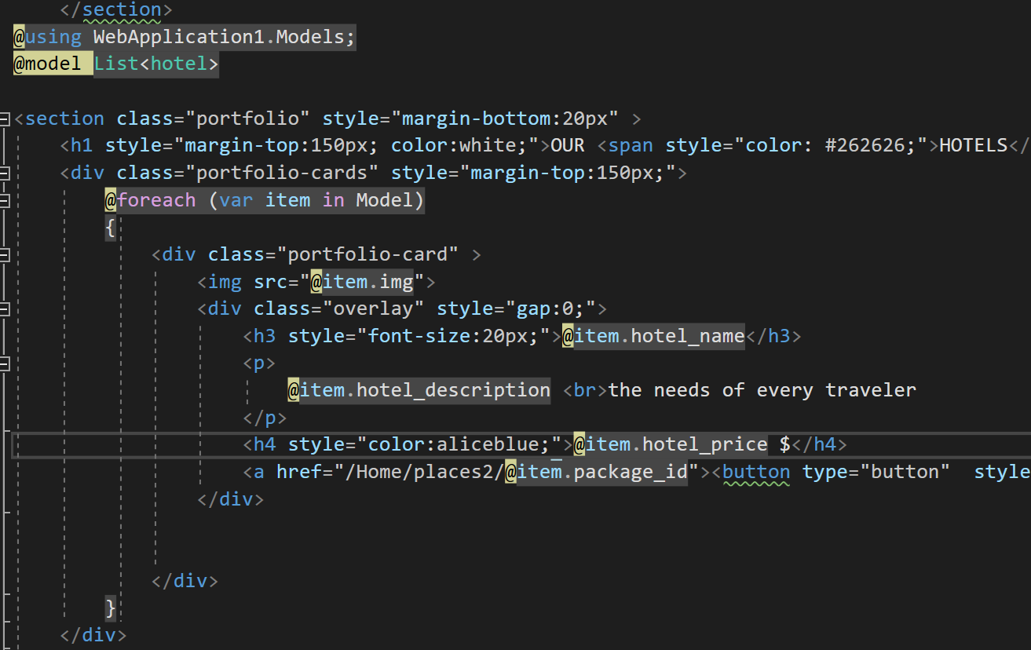

**IT DOES THAT BY SHOW THE RESULT WITH SAME PACKAGE ID**

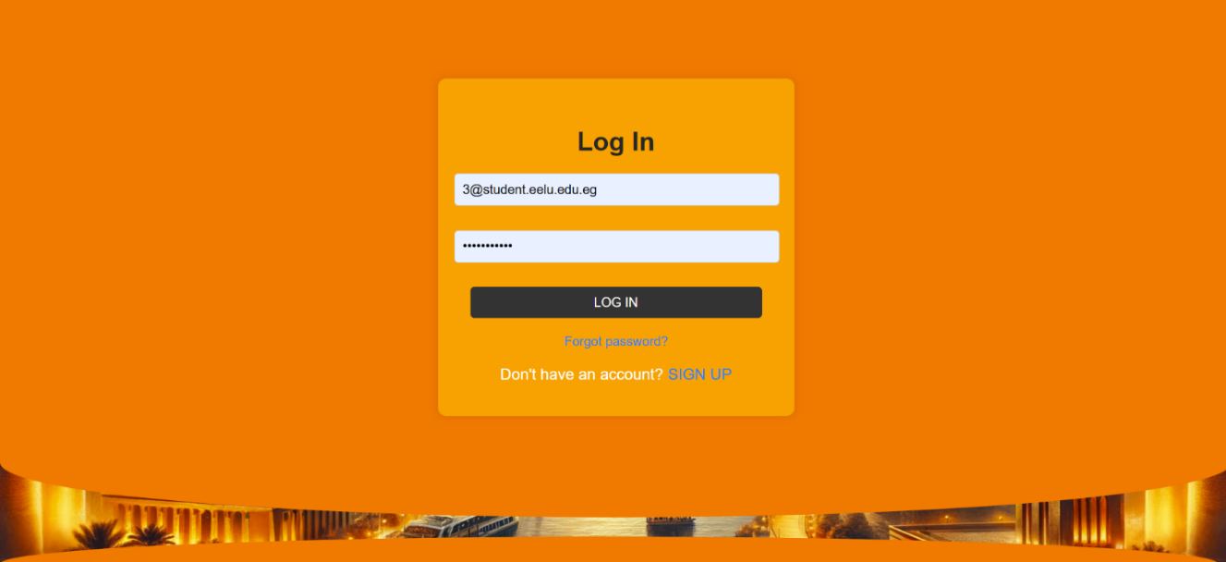

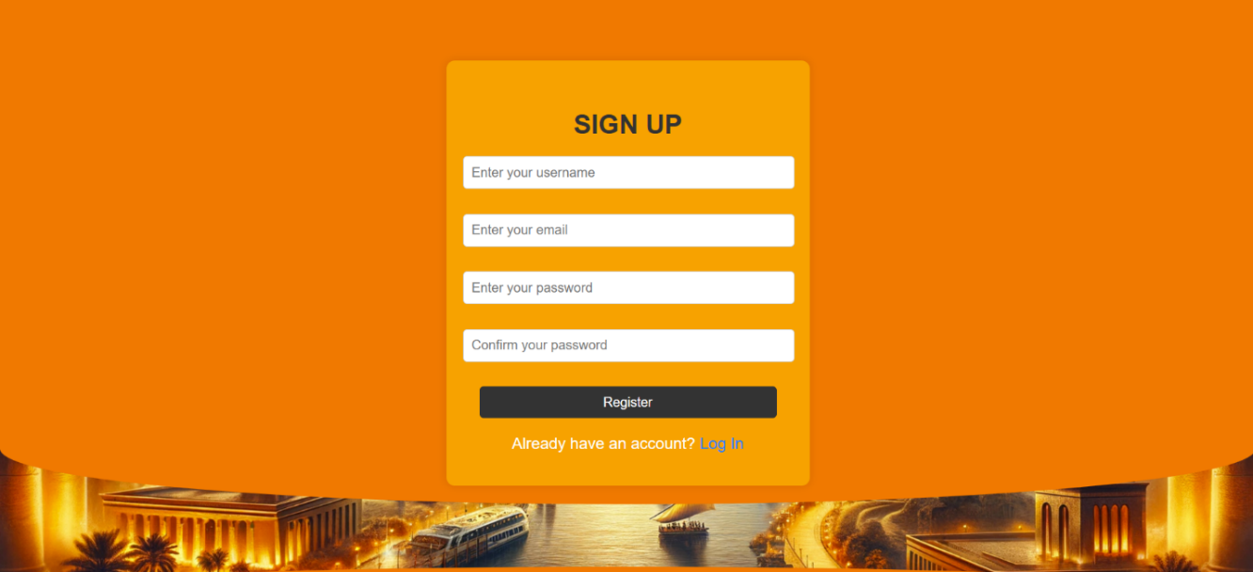

**LOGIN AND SIGN UP PAGES SAVE NEW USERS OR LOGIN THE USER TO THE WEBSITE**

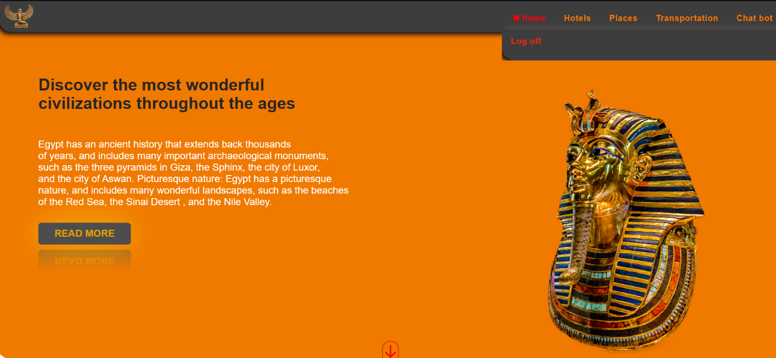

**WHEN THE USER LOGIN THE LOGIN AND REGISTER BUTTONS DISAPPEAR**

**AND INSTEAD OF THEM IT SHOWS A LOG OFF BUTTON IF THE USER WANT TO EXIT OR LOGIN WITH ANOTHER**

**ACCOUNT.**

**Chapter 4**

**Mobile Application**

1. **Splash screen:**

Inaugural pages are three pages simply designed using drawings and clipart to show the app features and mission to the user before login or register. These pages only appear at the first-time use of the app

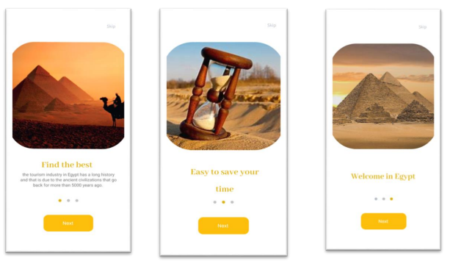

1. **Code Implementation**

Onboarding screen, we through some text and images to show the idea of the app and its specifications, after the navigation finishes app goes to Login page.

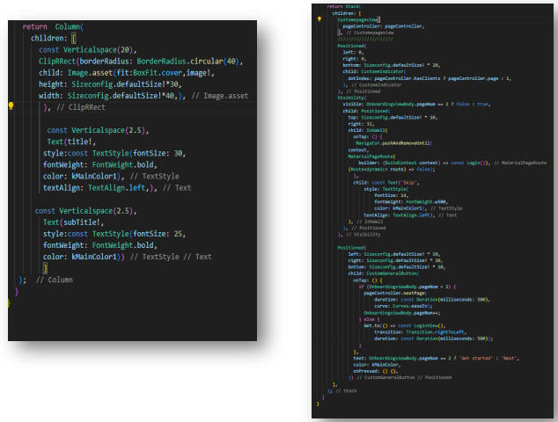

1. **Registration and Login pages:**

**Login page:**

A login page is an entry page to the application that requires user identification and authentication, regularly performed by entering a username and password combination. Logins may provide access to an entire site or part of the app, this is the first procedure after the inaugural pages, and he must add his email and password, if the user does not have an account, go to the registration page.

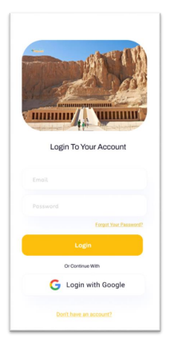

**Containing:**

* Image.
* FIELD FOR EMAIL.
* FIELD FOR PASSWORD.
* OPTION “CREATE AN ACCOUNT”
* Option “FORGET PASSWORD”.
* OPTION “RESET PASSWORD”.
* OPTION “LOGIN WITH

GOOGLE ACCOUNT”.

Code Implementation:

This function makes a sign in with email and password in firebase and handles the firebase authentication exception.

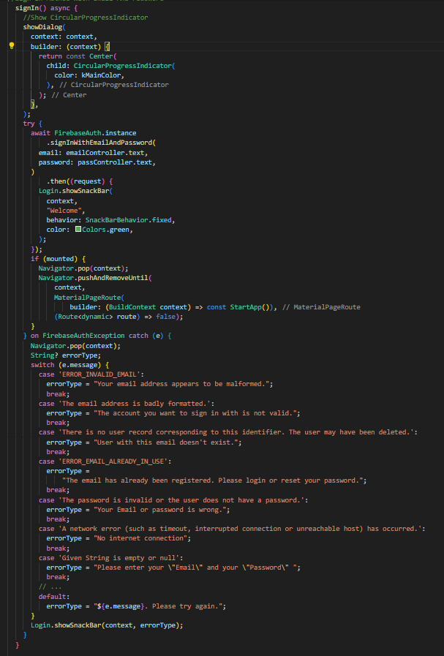

Forgetting Password Page:

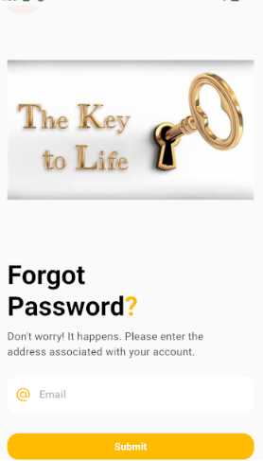-On the login page, when we click on Forgot password, a password reset page appears, and we type Gmail so we can reset the password. After you press Send, Firebase sends an email to Gmail that's written so that the password can be changed.

Code Implementation:

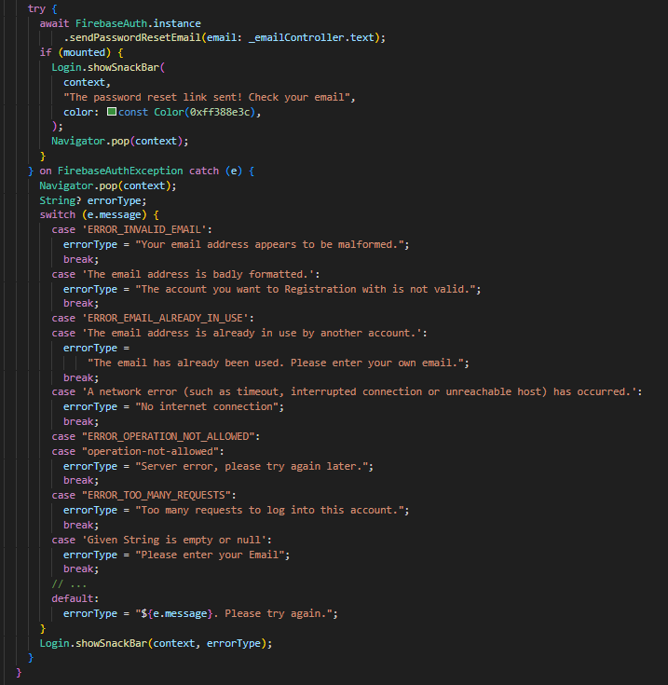

Registration Page:

1.1 A registration form is a list of fields that a user will input data into and submit to a data base, he must add his:

* + - 1. Username.
      2. Email Address.
      3. Password.

An option is added to the page “already have an account?” to be pressed if the user entered the registration page by mistake.

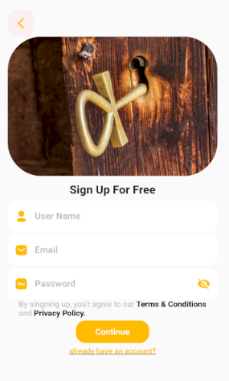

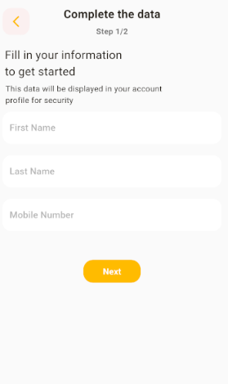

1.2 Completing the registration form, the user should enter his:

* + - * First name.
      * Last name.
      * Mobile number.

To make it more communicative between users, and tourism application using search or phone calls.

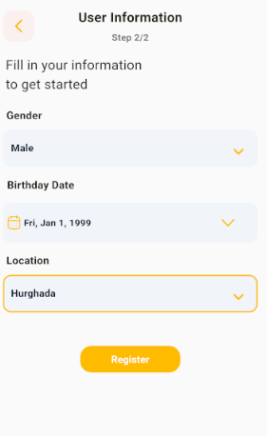

1.3 Perfecting the registration, data are required from user to increase the app’s ability to categorize the user according location.

* + - 1. Gender.

1. Birthday Date.
2. Location.

Code Implementation:

This function makes a sign up and create user with email and password in firebase fire store and handles the firebase authentication exception.

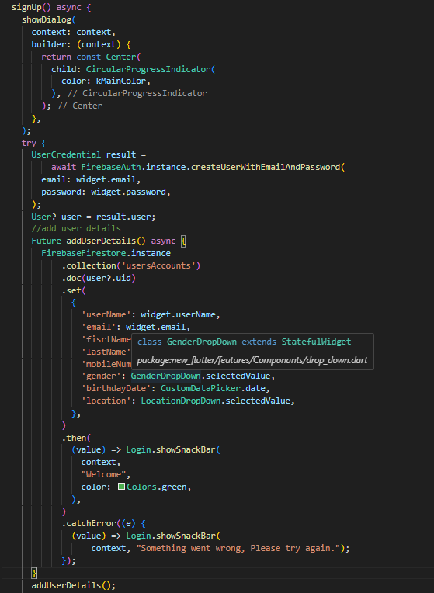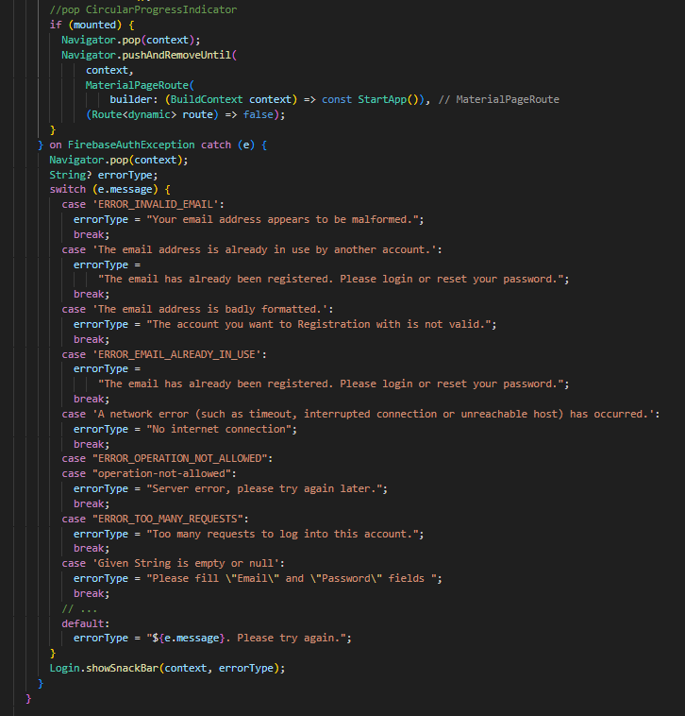

* + 1. Home Screen

Head:

Logo: At the top of the screen there is a logo that says “Egypt.io”.

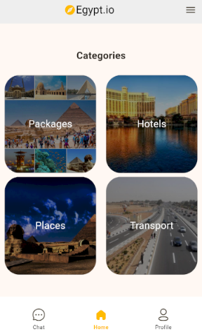Menu Icon: At the top right, there is a menu icon (three horizontal lines), indicating that users can access additional options or settings.

Title: The main section is titled “Categories”.

Category Grid: There are four categories displayed in a grid format with rounded square images and labels:

**Packages**: The image contains a collection of different Egyptian landmarks, including the pyramids and other historical sites. It offers the most historical places in Egypt.

**Hotels**: The picture shows a luxury hotel next to a body of water, which indicates hotels with a good rating.

**Places**: The image depicts famous landmarks, including the Sphinx and the Pyramids, suggesting many interesting places in Egypt.

**Transportation**: The picture shows a highway with vehicles, indicating transportation options within Egypt.

**Footer navigation**:

**Chat**: An icon for a chat, perhaps to contact support or get help.

**Home**: The home screen icon, highlighted in yellow, indicates that this is the current screen.

**Profile**: Icon for a user profile, where users can manage their personal information and settings.

Overall, this screen acts as a dashboard for users to explore different aspects of planning their trip to Egypt, including finding hotels, discovering places of interest, and arranging transportation.

Code Implementation:

Reading data from Firebase, if necessary, it protects it and then appears to the user using a special number for each package page.

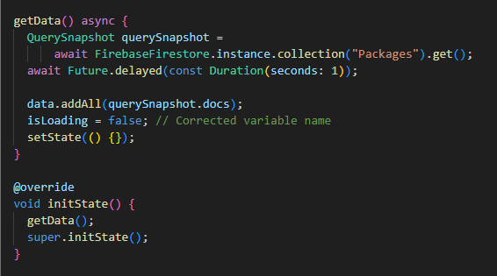

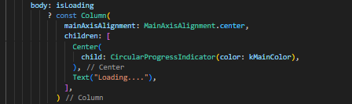

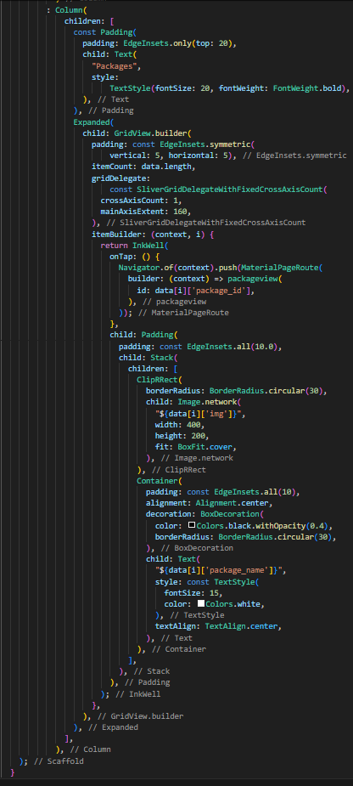

* + 1. Packages Pages:
  1. This page contains 6 packages, each package contains 10 hotels and 10 places according to the type of each package and also according to the special number.

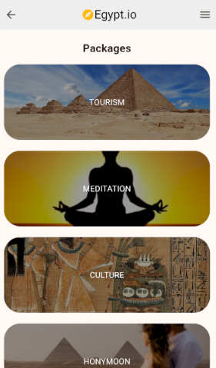

* 1. When choosing a package, a new page appears with two categories: hotels and places, each of which contains a group of the best-rated Places and Hotels.

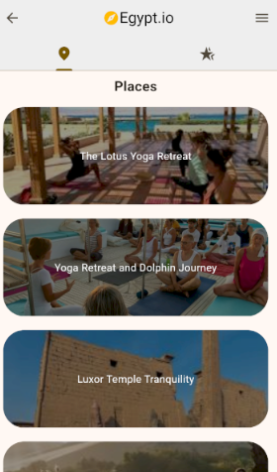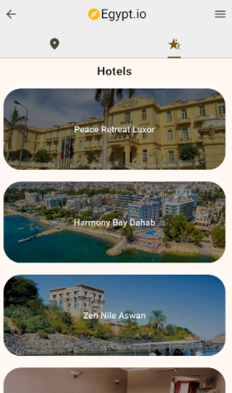

Code Implementation:

1.1 This data is retrieved from Firebase using a special number corresponding to each package, as we explained previously.

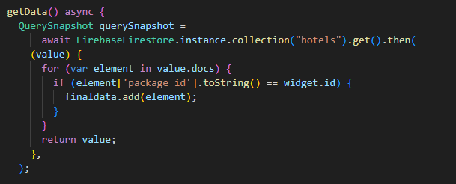

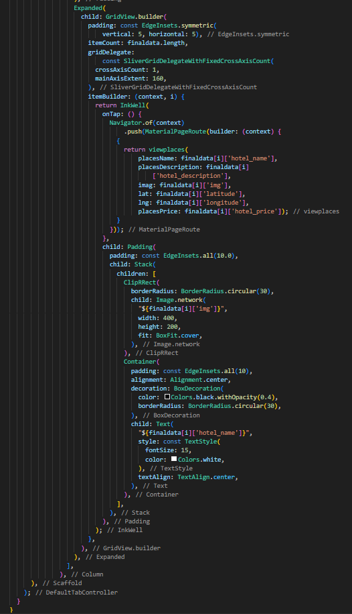

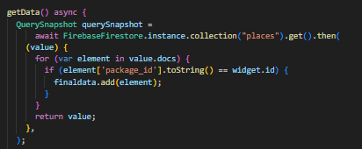

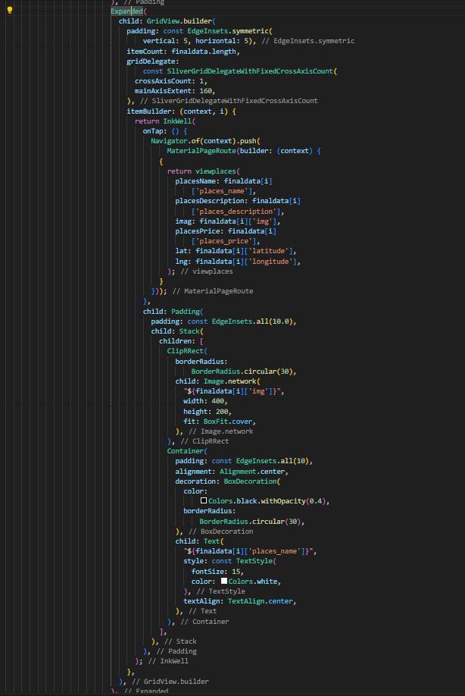

* 1. When you select the card from existing hotels or places, it displays a picture of the place and provides information such as: name, description, and price.

At the bottom of this page there is a button to get the site.

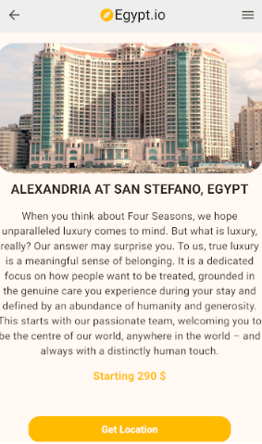When pressed, it opens a Google Map page, obtains the user's location and plots a route to the chosen place or hotel.

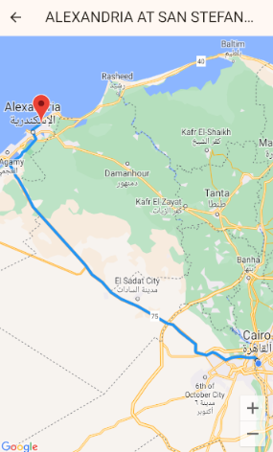

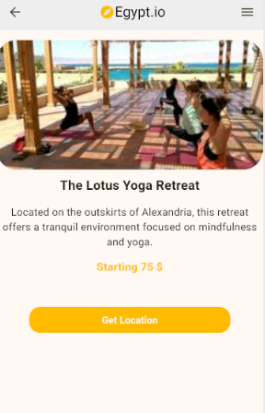

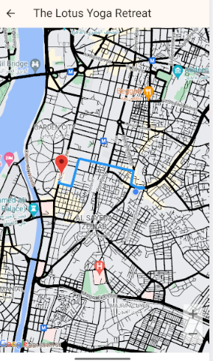

Code Implementation

This function retrieves the information for each place and its location**.**

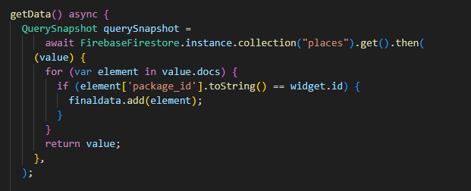

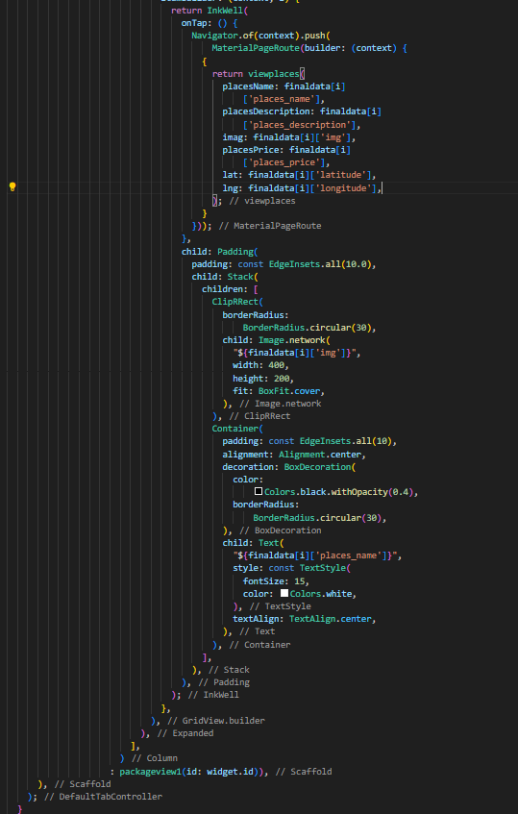

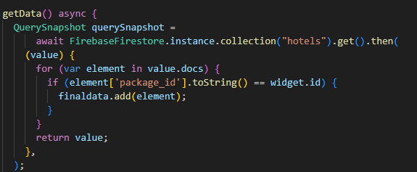

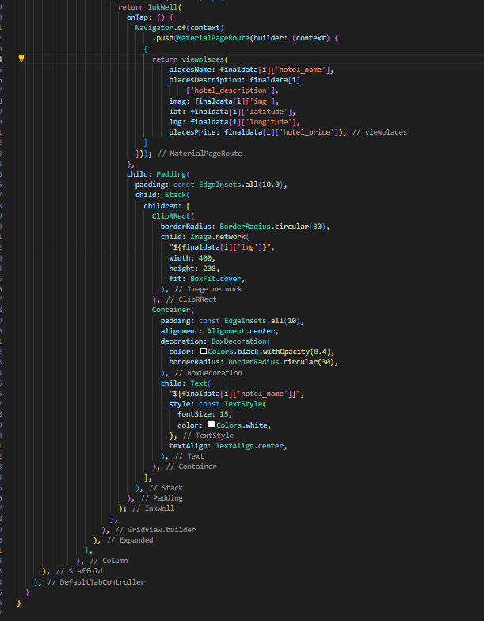

* + 1. Hotels and Places page

This page contains information about hotels and places recommended to the user. It has more than 20 hotels and tourist places.

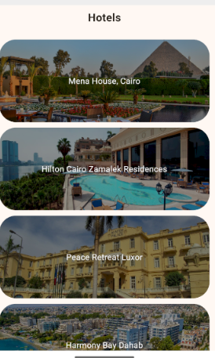

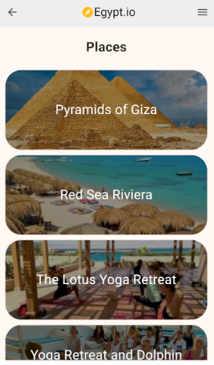

Code Implementation:

As we previously explained how to retrieve data from Firebase.





* + 1. Transports Page:

1.1 The transportation page displays the most commonly used means of transportation and the best prices.

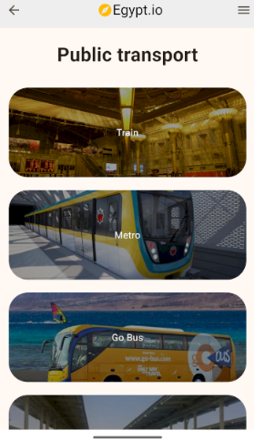

Code Implementation:

Get data from Firebase.

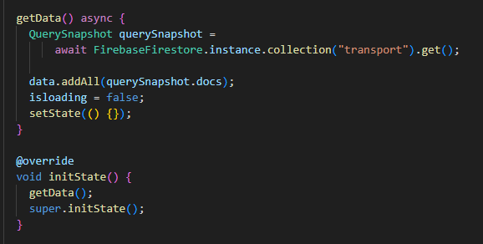

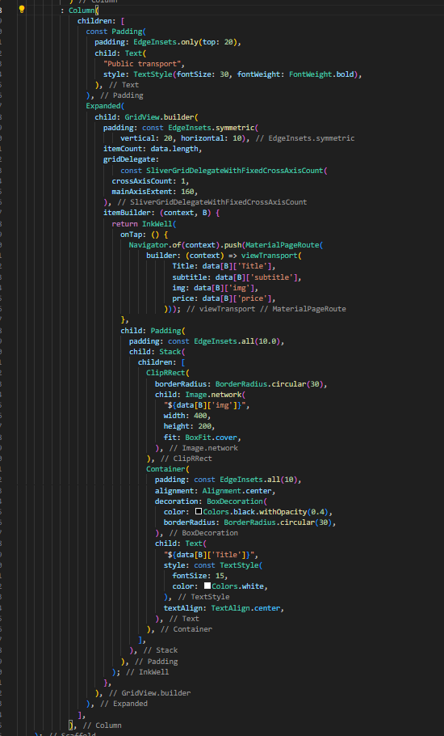

1.2 On this page, when you choose a metro or train card or any other one, a page opens with information about the chosen means of transportation.

At the bottom there is a button to get the location. When pressed, it opens Google Map and obtains the user’s location. It also obtains the location of the stations and draws a route to the nearest station.

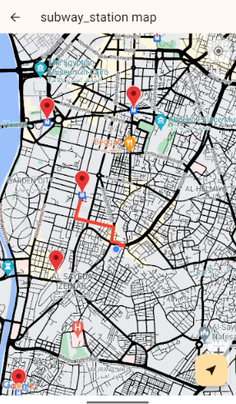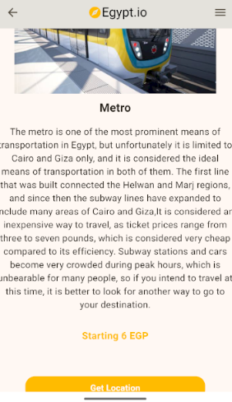

Code Implementation:

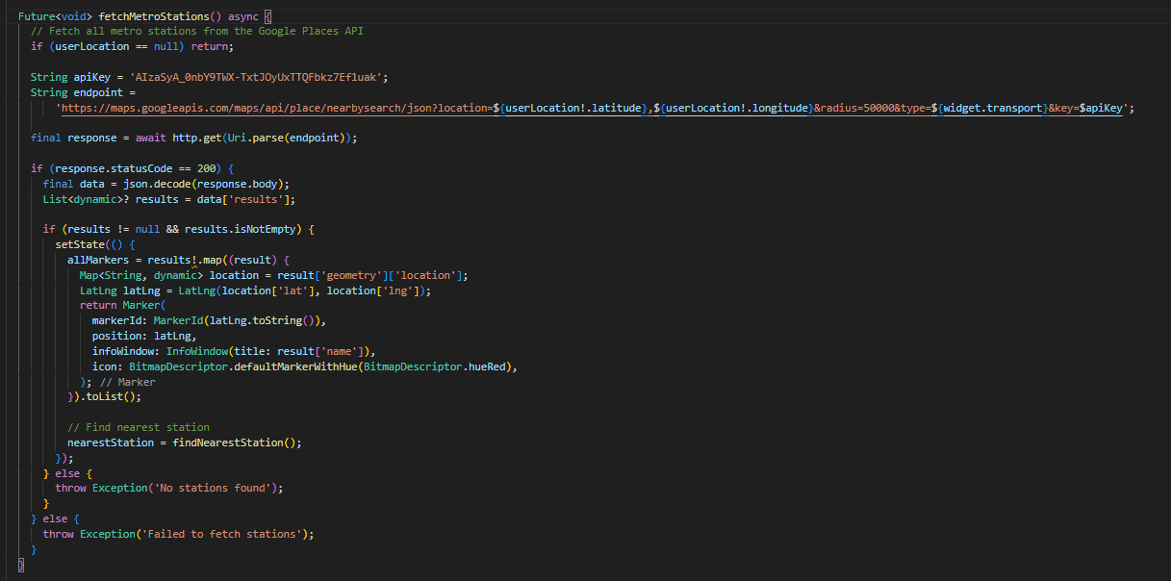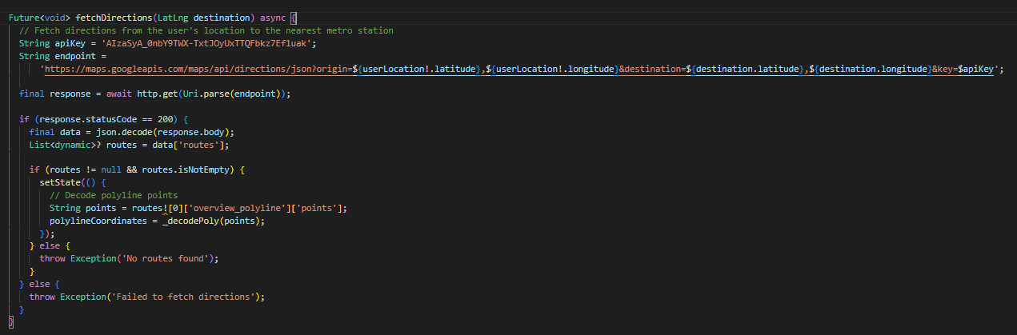 Here we obtained the API from Google Map so that we can find metro, bus and train stations and draw a route to the nearest station.

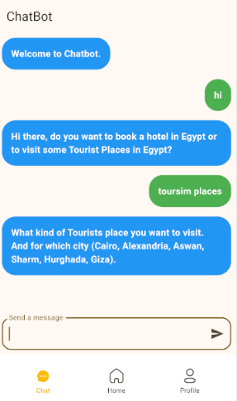5.1.7 Chat Page:

**Conversation**:

The chatbot begins with a welcome message, then the conversation begins, and the chatbot asks what the user’s interests are, whether booking hotels or visiting tourist places.

When the user responds to it, it gives him the appropriate places for him and also gives him the location of the place in the form of longitude and latitude.

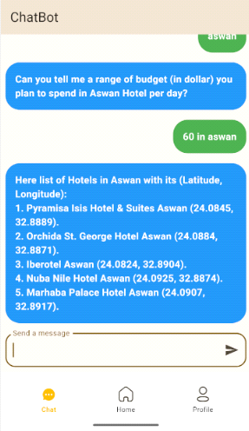

Code Implementation:

Here we have created a link between the program and the chatbot so that the user can connect to it if needed.

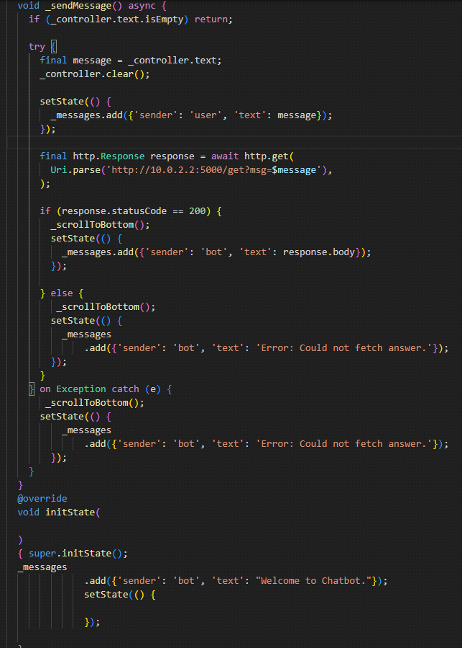

5.1.8 Profile Page:

* 1. Profile photo placeholder: At the top, there's a circular profile photo placeholder, represented by a generic icon of a person.

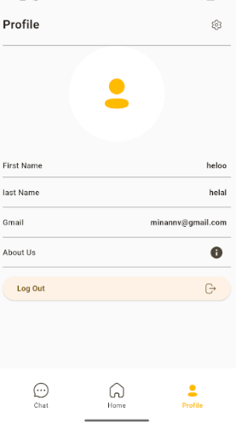**User information**:

-First Name.

-family name.

-Gmail.

**About Us**: There is a section titled “About Us”, but there is no additional information available in this screenshot.

**Log out button**: Below the user information, there is a “Log out” button with a lock icon next to it.

**Navigation bar**: At the bottom of the screen there is a navigation bar containing three icons:

**Chat**: represented by a speech bubble icon.

**House**: represented by the house symbol.

**Profile**: Represented by a person icon, which is highlighted to indicate that the user is currently on the profile page.

* 1. On the profile page, the settings icon is located at the top left. When we click on it, another page appears with two options:

**- Personal information.**

**-forgot your password.**

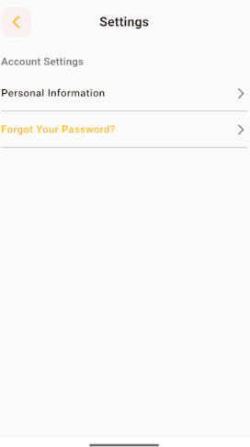

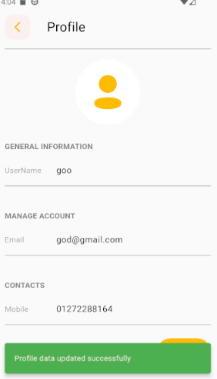

1**.3** When you click on the Personal Information option, the data update page appears, Through it we can change:

-**Username.**

-**Gmail.**

-**phone** **number.**

After writing these two statements, we click on the word “**Update**” and we find it at the beginning of the page to the left, then the word “**OK**” appears at the bottom of the page, and then the data is updated directly in Firebase.

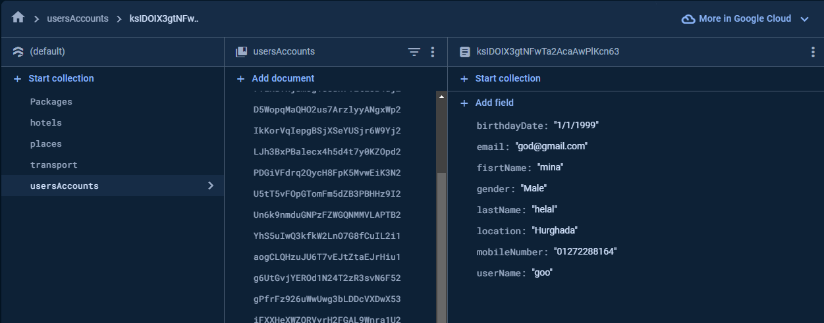

Code Implementation:

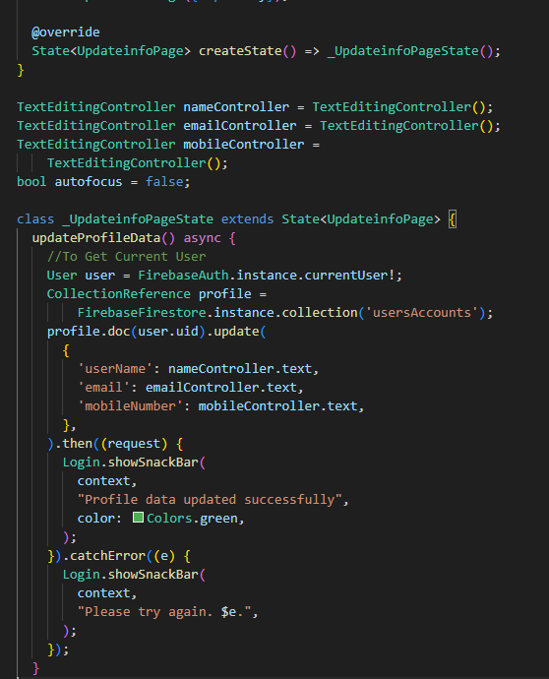This function allows us to update data in Firebase.

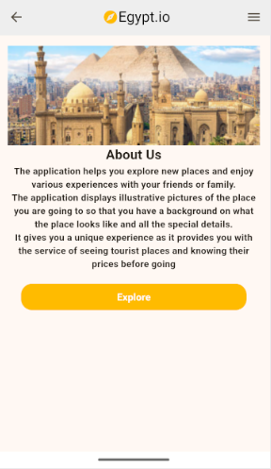5.1.9About Us Page:

The top of the image contains a header with the app's name and logo, which includes a pyramid-shaped icon. Below the page header is a background image showing a stunning view of Egypt, including the famous pyramids and a mosque, likely representing the country's historical and cultural landmarks.

The main content of the image is a section titled “About Us,” which provides a description of the purpose of the app. The text says:

"The application helps you explore new places and enjoy various experiences with your friends or family. The application displays illustrative images of the place you are going to so that you have a background on what the place looks like and all the special details. It gives a unique experience as it provides you with the service of seeing tourist places and knowing their prices beforehand." Go for it."

At the bottom of the section is a yellow button called “Explore,” which will likely serve as an invitation for users to start using the app and discover more about tourist destinations in

**Chapter 5**

**Chatbot**

* + there are 4 most important files in our Chatbot project, which are:
  + data.json (file contain data, that model will train on).
  + training.py (in this file we build our model and train the model on data in data.json file then extract the model in external file called model.h5).
  + model.h5
  + app.py (this is the flask file that the model loaded in start the chatbot on web browser by using python flask framework).

**Some images for the output:**

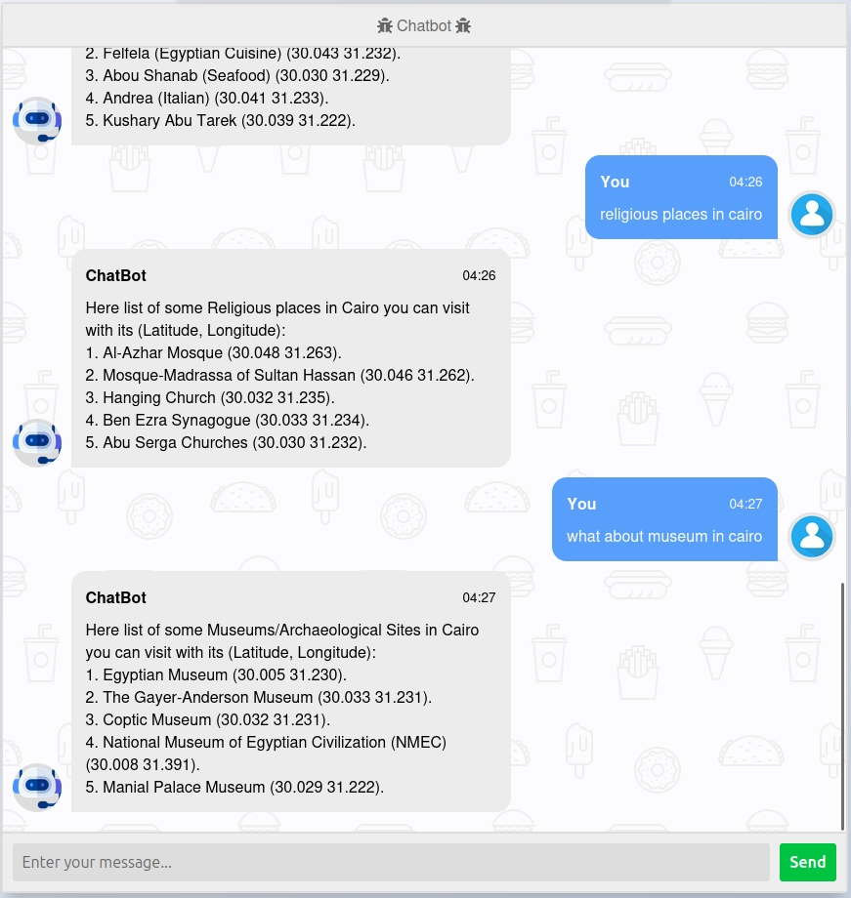

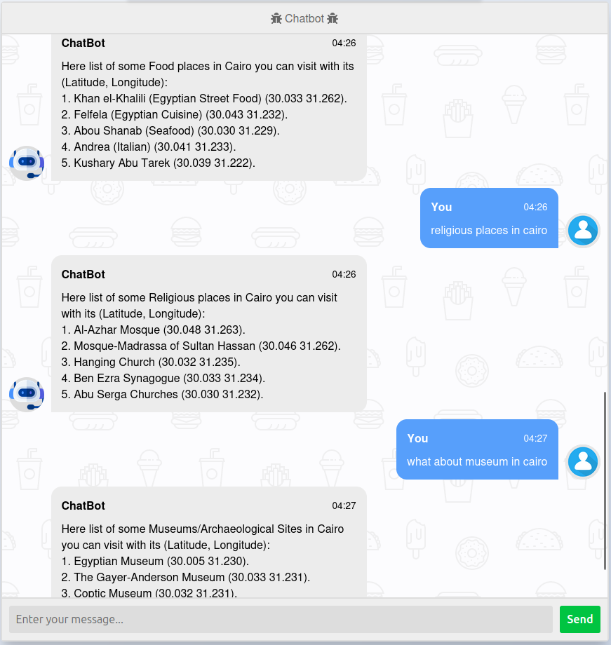

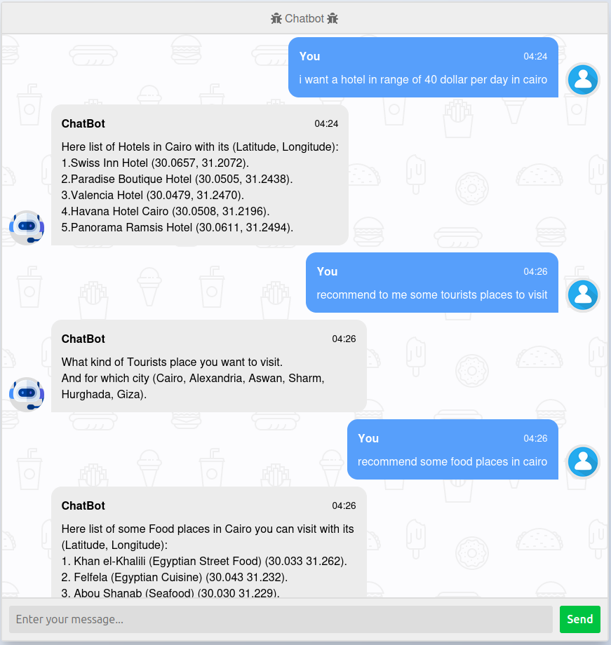

**image for data.json :**

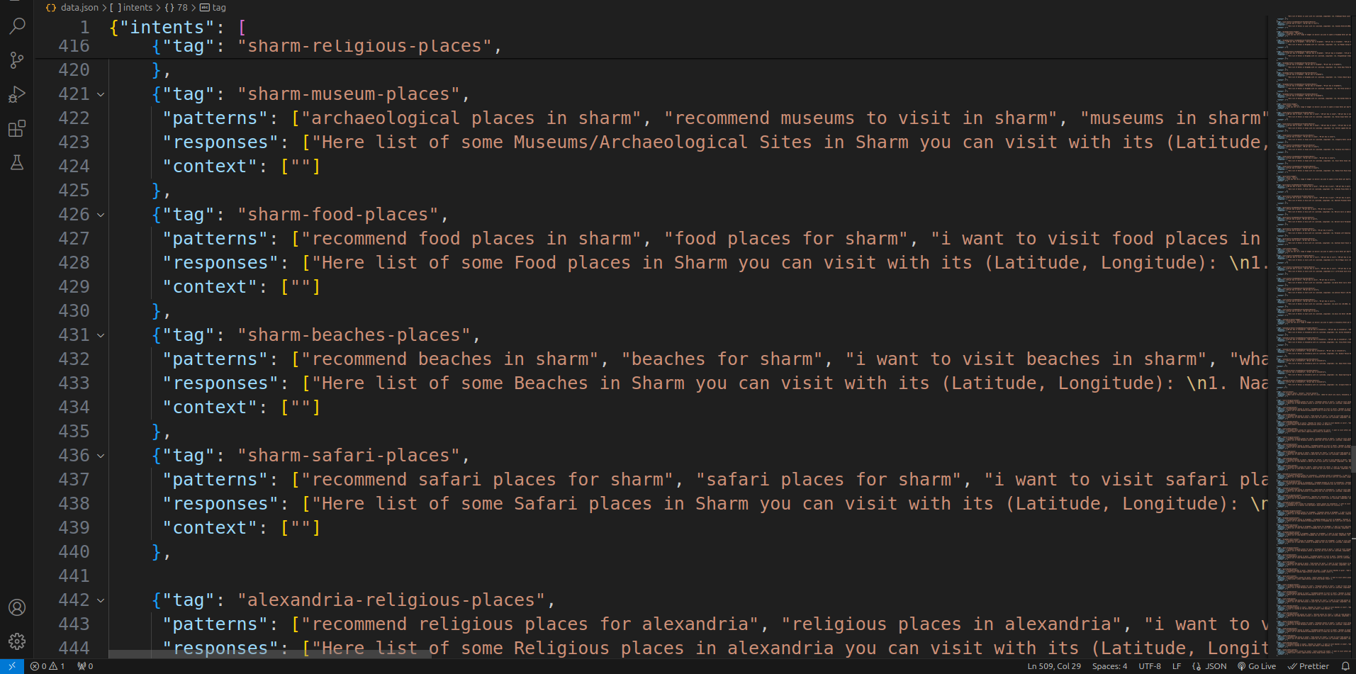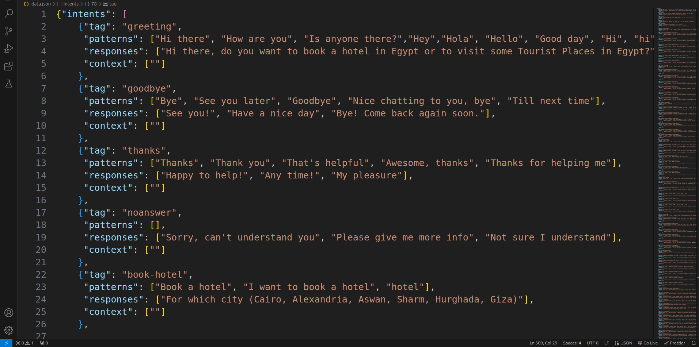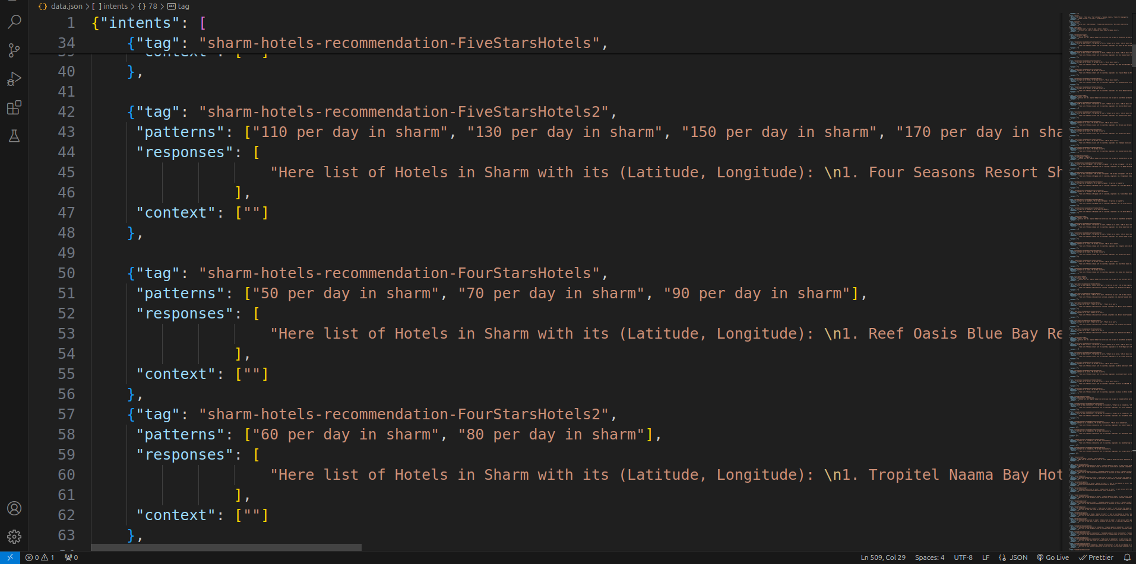

**image for code of training.py:**

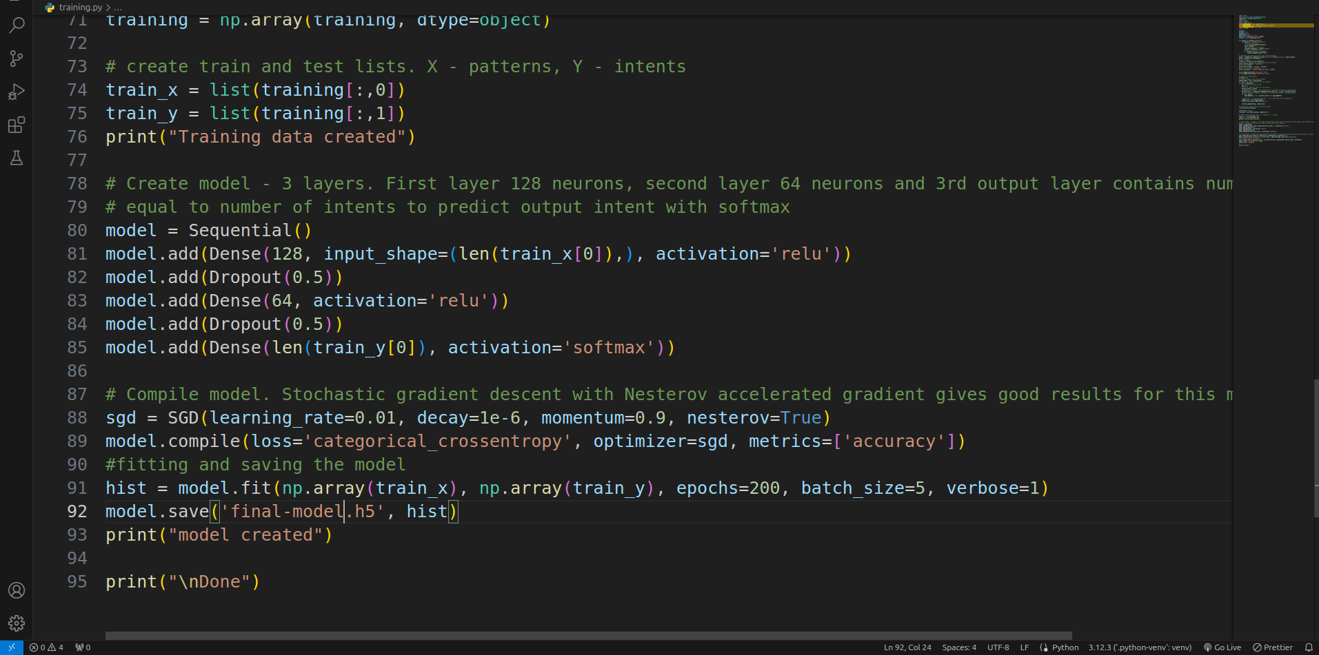

**image for code inside app.py**

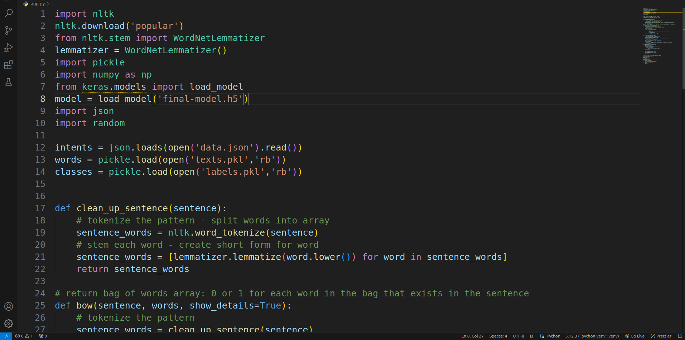

**CONCLUSION:**

In summary, the combination of a Tourism Guide Chat-Bot and a dedicated Tourism website in Egypt offers a comprehensive solution to cater to the needs of travelers. While the Chat-Bot provides instant, personalized assistance and recommendations, the website serves as a centralized platform for detailed information, bookings, and itinerary planning. Together, they enhance accessibility, convenience, and satisfaction for tourists, contributing to the growth and promotion of Egypt's tourism industry. This integration leverages technology to provide seamless and efficient support, ensuring a memorable experience for visitors exploring the wonders of Egypt.

## 

## Reference

* + <https://flutter.dev/>
  + <https://developer.mozilla.org/en-US/>
  + <https://realpython.com/>
  + <https://www.fast.ai/>
  + [https://docs.flutter.dev/development/ui/advanced/sp](https://docs.flutter.dev/development/ui/advanced/splash-screen)

[lash-screen](https://docs.flutter.dev/development/ui/advanced/splash-screen)

* + https://docs.flutter.dev/development/data-

[andbackend/firebase](https://docs.flutter.dev/development/data-and-backend/firebase)

* + <https://firebase.flutter.dev/docs/overview/>
  + <https://www.kaggle.com/>
  + <https://firebase.flutter.dev/docs/storage/overviw>
  + <https://firebase.flutter.dev/docs/firestore/overview>
  + [https://dart.dev/guides\](https://dart.dev/guides/)
  + https://[www.youtube.com/c/Firebae](http://www.youtube.com/c/Firebae)
  + <https://firebase.google.com/podcasts/firebase-show>